

VIETNAM NATIONAL UNIVERSITY HANOI
International school

----------

Multimedia Design and Web Development
Class code : INS306402

Final Project
Topic : Building software to sell motorbikes for Vinamotor stores on the web
Lecturer : ThS Xuan Truong Nguyen

Group : 2

Student Name : Student ID:
Nguyen Huong Diu 22071022
Nguyen Khanh Duy 22071055
Do Duc Hieu 22070892
Nguyen Quynh Chi 22071081

Hanoi - 7th June 2025

TABLE OF CONTENTS 1
CHAPTER 1. SYSTEM OVERVIEW 3
  - Reasons for choosing a topic 3
  - Objectives of the project 4
  - Scope of the topic 5
  - Expected Results 6
  - Survey of the current situation 8
    - Survey objectives 8
    - Survey Methodology 8
    - Survey Results 9
  - Conclude 10
CHAPTER 2. THEORETICAL BASIS 11
  - Theoretical basis 11
    - The concept of e-commerce 11
    - Basic Components in E-Commerce 11
    - Business models in e-commerce 12
  - Tools to use 13
    - PHP 13
    - MySQL 14
    - HTML, CSS 15
    - Javascript 16
    - Framework Bootstrap 17
    - jQuery Library 18
  - Conclude 19
CHAPTER 3. SPECIFICATION AND DESIGN ANALYSIS 20
  - System Analysis 20
    - Analyze the agents and operations of the system 20
    - Use case analysis 23
    - Specification Analysis 30
  - Website Design 40
    - Backend Design 40
      - Databases 40
      - Analyze the class diagram 44
      - ERD Diagram Analysis 45
    - Frontend design 46
    - Activity Chart Design 48
    - Sequential chart design 54
  - Conclude 59
CHAPTER 4. SYSTEM INSTALLATION AND TESTING 60
  - Program Installation 60
  - Program Testing 62
  - Conclude 62
CHAPTER 5. CONCLUDE 63
  - Interface 63
  - Results Achieved 71
  - Development direction 71
  - Conclude 72
REFERENCES 73

CHAPTER 1. SYSTEM OVERVIEW

Reasons for choosing a topic
In the context of an increasingly developing economy, people's travel needs are also constantly increasing, especially personal vehicles such as motorbikes. In Vietnam, motorbikes are still the most popular means of transportation thanks to their convenience, reasonable cost and suitability for traffic infrastructure conditions. Therefore, motorcycle shops, especially genuine distributors such as Vinamotor, are always looking for ways to improve service quality to meet the needs of customers in the best way.
However, the majority of motorcycle shops today still apply the traditional business model, mainly selling directly at the store. This leads to a number of limitations such as limited customer reach, suboptimal product and order management processes, and easy to make mistakes in the business process. At the same time, customers also have difficulties when they want to find out information about the car, having to go to the store to see the product, causing time and effort.
Meanwhile, with the strong development of e-commerce and web technology, building an online motorcycle sales system is a necessary solution to help expand the market, improve the shopping experience, and optimize the store's management process. A web-based motorcycle sales software system will help customers easily look up vehicle information, view product details, compare prices and order online quickly.
In addition, this system also supports warehouse management more effectively, helping to update the number of available vehicles automatically, limiting out-of-stock without notification. Features such as order management, transaction status tracking, and online payment method integration also help increase professionalism and convenience for both stores and customers. In particular, the system also helps the store easily implement promotions and promote products through the online platform, thereby attracting more potential customers.

With the above outstanding benefits, building motorcycle sales software for Vinamotor stores on the web not only helps improve business efficiency but also creates a modern sales channel, meeting the current trend of digital transformation. Therefore, our team decided to choose this topic with the desire to apply technology to optimize business activities, contributing to promoting the development of stores in the digital age.

Objectives of the project
The main goal of the project "Building software to sell motorbikes for Vinamotor stores on the web" is to build a modern e-commerce platform, meeting the needs of buying motorbikes quickly, conveniently and efficiently for both customers and managers. Specifically, the system needs to achieve the following goals:

For customers
    - Provide a user-friendly, easy-to-use interface that makes it easy for customers to search for and refer to product information.
    - Support customers to register, log in, forget passwords, and manage personal information securely.
    - Allow customers to search for products by various criteria such as name, category, price.
    - Support the shopping cart feature, making it easy for customers to add, modify, or delete products before purchasing.
    - Provides a simple and efficient ordering process, ensuring customers can track the status of their orders.
    - Allow customers to review and comment on products after purchase, helping other users have more reference information.
    - Provide order history so customers can review past transactions.

For Admins
    - Build a catalog and product management system, making it easy for admins to add, edit or delete products.

    - Provide customer account management functions, support user control in the system.
    - Support order management, help Admin track and process orders from customers accurately and quickly.
    - Build a reporting system, statistics on revenue, number of products sold, help managers have an overview of business performance.

Technically
    - Build a system with a security architecture, ensuring the safety of user information and transaction data.
    - Optimize data retrieval speed, making the system operate quickly and stably.
    - The system design is easy to expand and upgrade in the future.
    - Apply the right technologies to ensure the availability and efficiency of the system.
With the above goals, the system not only helps customers have a better shopping experience but also supports managers to manage sales effectively, thereby improving business performance and meeting current e-commerce trends.

Scope of the topic
The scope of the topic "Building software to sell motorcycles for Vinamotor stores on the web" is limited to building an e-commerce system that allows customers to shop for motorcycles. Specifically, the scope of the topic includes:
System functions: For customers: The system provides functions such as registering an account, logging in, searching and viewing product listings, managing shopping carts, placing orders, reviewing products, and viewing order history. For admins: The system allows admins to manage products, categories, orders, customer accounts, and track revenue statistics, the number of products sold.

Customers using the system: The system caters to individual customers who want to buy motorcycles, from beginners looking for products to those who have logged in to manage their information and orders. An administrator is a person who is responsible for maintaining and managing the entire operation of the system, including managing products, orders, and customers.
Technology and platform used: The system will be developed using modern web technologies, including PHP (Laravel), MySQL for databases, and HTML, CSS (Bootstrap) for the user interface. The system will be deployed on a web platform, which can be accessed from a computer or mobile device through a browser.
Limitations and exclusions: The topic does not include the implementation of online payment methods such as credit cards and e-wallets in addition to basic payment methods. The system does not have a direct delivery function, but only supports ordering and order notification to the Admin. The system will not include the development of mobile applications, but only in the form of a website. With this scope, the project focuses on building a simple but effective web-based motorcycle sales software for Vinamotor stores, serving the shopping needs of customers and supporting the management work of Admins.

Expected Results
The project "Building software to sell motorbikes for Vinamotor stores on the web" aims to build a complete e-commerce platform, meeting the needs of customers and administrators. The expected results achieved after the implementation of the system include:

For customers
    - Enhanced user experience: The system will provide an easy-to-use and user-friendly interface, making it easy for customers to search, select, and purchase products.
    - Increase product accessibility: Customers will be able to quickly look up products through advanced search features such as

Search by name, category, price, save time and find the right product.
    - Cart and order widgets: Customers will be able to easily add, edit, and delete products in their carts, and track the status of their orders, thereby improving satisfaction during the shopping process.
    - Product reviews and feedback: Customers can leave comments and product reviews after purchase, which helps the system improve service quality and help other users have reference information when shopping.

For Admins
    - Efficient product and catalog management: Admins will easily manage catalogs, add, edit, delete products, and update product details as needed, helping to ensure that the system is always up to date with the latest products.
    - Order management and statistics: Admin will be able to track and process orders, update the status of orders and track revenue reports, the number of products sold. This helps the Admin to have an overview of business activities.
    - Customer account management: The system will allow Admins to view and manage customer account information, thereby helping to secure and support customers quickly if problems arise.

Technically
    - Security and stability: The system will be developed with reasonable security measures to protect user information and online transactions. This includes the security of customer account data and order information.
    - System Performance: The system will be optimized for speed and scalability, ensuring smooth operation even with a large number of users and multiple products.

    - Future Scalability: The system will be built with an easily scalable structure, allowing for the addition of new features in the future without experiencing complex system structure issues.
Thus, the expected result of the project is to build a complete, user-friendly, efficient management and security software for Vinamotor stores on the web, thereby improving customer experience and business performance of the store.

Survey of the current situation

Survey objectives
The objective of this survey is to assess the current status of software for selling motorbikes for Vinamotor stores on the existing website in the market, in order to:
      - Analyze customer needs: Identify important factors that customers are interested in when buying a motorcycle, such as user interface, product search features, shopping carts, checkouts, and product reviews.
      - User satisfaction assessment: Determine the level of customer satisfaction with current online sales systems, thereby finding out the strengths and weaknesses of these systems.
      - Understand admin needs and requirements: Identify the functions required in the admin management system, including managing products, orders, user accounts, and revenue statistics.

Survey Methodology
To collect information and assess the situation, we use the following survey methods:
      - Questionnaire: Issuing an online questionnaire to end users and administrators of motorcycle sales software for stores. The questions will revolve around factors such as the features needed, the level of use of the functions, satisfaction with the user interface, and the shopping experience.

      - In-depth Interviews: Conduct interviews with several administrators of motorcycle shops to gather detailed information about their difficulties, requirements, and desires in the process of managing the system.
      - Observe and analyze current systems: Learn and analyze popular motorcycle sales software for stores today to evaluate features, user interfaces, and customer interactions.

Survey Results
The survey results show some key points as follows:
      - Important factors for customers:
        - Product search: 80% of survey respondents said that searching by product name, category, price, and other criteria is one of the most important factors when buying online.
        - User interface: Most customers (85%) require the interface to be user-friendly, easy to use, and intuitive.
        - Payment process: 75% of users want to have multiple payment methods, especially supporting online payment methods such as credit cards, e-wallets.
        - Product reviews: 70% of customers say they regularly consult other users' product reviews before making a purchase decision.
      - Evaluation of current systems:
        - Interface and features: Current systems mainly only meet basic needs such as product search and payment, but lack advanced features such as order tracking, product reviews, or easily updating personal information.
        - Customer support and after-sales care: Many customers believe that current systems do not provide enough customer support channels or clear instructions during the purchase process, especially when encountering problems.

      - Administrator Needs:
        - Product and order management: 90% of admins require product management, order status updates, and revenue reporting tracking with ease.
        - User account management: Administrators also expect the ability to manage user accounts, including verifying accounts and tracking customer shopping activities.
The survey results show that customers and administrators alike want a more powerful mobile sales software for stores, with advanced search features, convenient payments, and the ability to manage products and orders effectively. These results will help guide the design and implementation of the system in the graduation project.

CHAPTER 2. THEORETICAL BASIS

Theoretical basis

The concept of e-commerce
E-commerce is the purchase and sale of goods or services through electronic means such as the Internet. E-commerce consists of many different models, the most popular of which are:
      - B2C (Business to Consumer): Businesses that sell goods/services directly to consumers.
      - B2B (Business to Business): Transactions between businesses.
      - C2C (Consumer to Consumer): Consumers transact directly with each other through online platforms.
In the current context, E-commerce plays an important role in the global economy, with the strong growth of platforms such as Amazon, Alibaba, and Shopee.

Basic Components in E-Commerce
A typical e-commerce system consists of several key components:
      - User Interface (UI/UX): A user-friendly, easy-to-use, and highly interactive web interface that makes it easy for users to search, select products, and make transactions.
      - Content management system (CMS): A CMS allows admins to add, edit, and delete products, manage catalogs, update store-related information, and more.
      - Shopping Cart: Allows users to add products, calculate costs, taxes, shipping fees, and manage the checkout process.

      - Payment Gateway: Integrate secure online payment methods such as credit cards, debit cards, e-wallets (Momo, ZaloPay), or COD (Cash on Delivery).
      - Order and shipping management system: Allows order status tracking, delivery management, return support, product exchange.

Business models in e-commerce
Common business models in E-commerce include:
      - The Marketplace model: Platforms that allow independent sellers to list their products (Shopee, Lazada).
      - Subscription model: Users pay a recurring fee to receive a product or service on a recurring basis (Netflix, Spotify).
      - Direct-to-Consumer (D2C) model: Companies that manufacture products and sell them directly to consumers without going through intermediaries (Apple, Tesla).

Success Factors in E-Commerce
Some important factors that determine the success of an E-commerce project include:
      - User Experience (UX): Optimal, easy-to-use, and fast interface design that makes it easy for users to complete transactions.
      - Search Engine Optimization (SEO): Makes your online store easy to find on search engines like Google.
      - Security: Ensure the safety of user information and transactions through the system.
      - Omnichannel integration: Combine multiple online and offline sales channels to provide a seamless experience for consumers.

The development trend of e-commerce
E-commerce is constantly evolving with prominent trends such as:

      - Mobile commerce (M-commerce): The trend of shopping via mobile devices is increasing, requiring optimization of the mobile interface.
      - Artificial Intelligence (AI) and Machine Learning (Machine Learning): Helping to personalize the shopping experience and optimize store operations.
      - Augmented Reality (AR): Helps users experience products before they buy using augmented reality technology.
      - Blockchain and Cryptocurrencies: Enhancing Transaction Security and Supply Chain Management in E-commerce.

Tools to use

PHP
PHP (Hypertext Preprocessor) is a server-side programming language that is widely used in dynamic web application development. With its easy-to-understand syntax, PHP allows developers to build powerful functions such as form processing, database management, and interaction with website components. With its large community and extensive supporting documentation, PHP is a useful tool for creating reliable and flexible web applications.
PHP has a simple syntax, fast and compact, easy to learn and the time to approach PHP is shorter than other programming languages, so currently PHP has a lot of open source CMS such as: WordPress, OpenCart, NukeViet along with frameworks such as: Laravel, Symfony, etc Codeigniter, etc.


Figure 2.1: PHP icon
Advantages of PHP:
      - Easy to learn and use
      - Powerful support for databases
      - Open-source, free-to-use language PHP Cons:
      - Performance is a bit slow
      - Difficult source code management with large projects
      - No default security mechanisms

MySQL
MySQL is a popular and open-source database administration system that is widely used in web application development. With its high performance, scalability, and security, MySQL supports storing and querying data efficiently. It supports multiple programming languages and offers features such as TCP/IP protocol, HTTP protocol, and transaction management. MySQL is a popular choice for web projects that require consistency and reliability with data.

Figure 2.2: MySQL icon
Advantage
      - Advantages of MySQL:
      - High performance, fast data query

      - Reliable and stable
      - SQL Standard Support MySQL Cons:
      - Limited scalability
      - Limit high-end and complex features
      - Complex configuration management

HTML, CSS
HTML (Hypertext Markup Language) and CSS (Cascading Style Sheets) are two fundamental technologies in web development. HTML is a markup language primarily for building the structure and content of a website, while CSS is a language for styling and presenting HTML components. HTML defines the elements and structure of a page, while CSS defines the appearance, colors, formatting, and layout. The combination of HTML and CSS allows developers to create attractive websites that have a flexible design and are compatible on different devices.



Figure 2.3: HTML icons, CSS
Advantage:

      - As two basic and popular languages in web development, they are easily accessible
      - Support on all browsers and devices, helping to create cross-platform websites.
      - Simple and easy-to-learn syntax Cons of HTML and CSS:
      - Limited customizability
      - Must maintain cross-browser compatibility
      - HTML and CSS must be combined with other languages such as JavaScript to create complex and interactive web applications.

Javascript
JavaScript is a popular client-side programming language in web development. It allows for the creation of interactive, responsive, and dynamic websites. JavaScript provides features such as event handling, changing page content, creating graphic effects, and sending and receiving data from the server. Supported on all browsers, JavaScript is a powerful tool for making your website lively and user-friendly.

Figure 2.4: Javascript icons
Advantage
      - Integration directly into the browser

      - Highly interactive
      - Powerful Ecosystem Cons
      - JavaScript runs on the client, which can create security vulnerabilities if not handled carefully
      - Can cause slower performance than other programming languages, especially when handling large-scale or high-load software.

Framework Bootstrap
Bootstrap is a popular open-source frontend framework used for web user interface (UI) development. It was originally created by Twitter and later developed and maintained by the extensive open-source community. Bootstrap provides a suite of tools and documentation for building websites and web applications that are friendly to a variety of devices and screen sizes. Bootstrap allows the website design process to take place faster and easier based on the basic elements available such as typography, forms, buttons, tables, grids, navigation, image carousels, etc.



Figure 2.5: Bootstrap Icon
Advantage
      - Bootstrap Pros:
      - Easy to use
      - Responsive Design

      - Available interface components
      - Browser compatibility
      - Strong Community Cons
      - Limited customizability
      - Large Capacity
      - If not used carefully, the same look may result in

jQuery Library
jQuery is a popular JavaScript library released in 2006 by John Resig. It simplifies interacting with HTML documents (DOM), event management, animations, and AJAX with a concise, easy-to-understand syntax than using pure JavaScript.



Figure 2.6: jQuery Library
Advantage
      - Syntax Simplification
      - Browser compatibility
      - Easy AJAX support
      - Easy event management
      - Extensive plugin library
      - Create animations

Shortcoming
      - Inferior performance compared to pure JavaScript
      - Library Size
      - No longer needed with modern frameworks
      - Community Transitions to New Technologies
      - Not suitable for complex web applications

CHAPTER 3. SPECIFICATION AND DESIGN ANALYSIS

System Analysis

Analyze the agents and operations of the system
Customer: is the end user of the system, can refer to products on the web or make purchases
Without registration:
      - Registration: Customers can easily register a new account after entering all the information. The account can then be used to log in.
      - Product Search: Customers can search for products by product name or descriptions without logging in.
      - View product listings: Customers can view product listings by category
      - View product details: Customers can view product details by product name or descriptions without logging in.
Once registered
      - Login: Customers need to log in through this page, but will be granted separate permissions after a successful login
      - Forgot password: Users can enter their account and email to request a password re-issuance
      - Sign out: sign out of your current account
      - Manage personal information: After logging in, customers can add and update their information in their account, including passwords. In addition, you can lock your account yourself
      - Product Search: Users can search for products by keywords, categories, product types, and different prices to choose the right product

      - View product details: after searching for a product, users can view detailed information including the store's description, promotions, prices, and services
      - Cart management: Only customers who are logged in and have products in their cart can update (add quantity, edit, delete) products in their cart.
      - Purchase: A customer can place an order when there is at least one product in the cart. Select the shipping method and then the order will be sent to the Admin.
      - View order history: Customers can review the details of previously placed orders.
      - Product Reviews: Customers can rate the product after the order is completed.
Admin: is a website administrator who can act as a store owner to manage all activities on the web
      - Login: Customers need to log in through this page, but will be granted separate permissions after a successful login
      - Forgot password: Users can enter their account and email to request a password re-issuance
      - Sign out: sign out of your current account
      - Manage personal information: After logging in, customers can add and update their information in their account, including passwords. In addition, you can lock your account yourself
      - Product Search: Users can search for products by keywords, categories, product types, and different prices to choose the right product
      - View product details: after searching for a product, users can view detailed information including the store's description, promotions, prices, and services

      - Account management: Admin can view customer and administrator accounts, perform account locks, grant permissions
      - Catalog management: Admins can add, update, and delete categories
      - Product management: Admin can add, update, and delete products.
      - Order management: Admins can view orders that have been placed by customers, update the status of orders.
      - Statistics: Admin can track statistics on the number of products sold and the revenue of the website, the number of products.

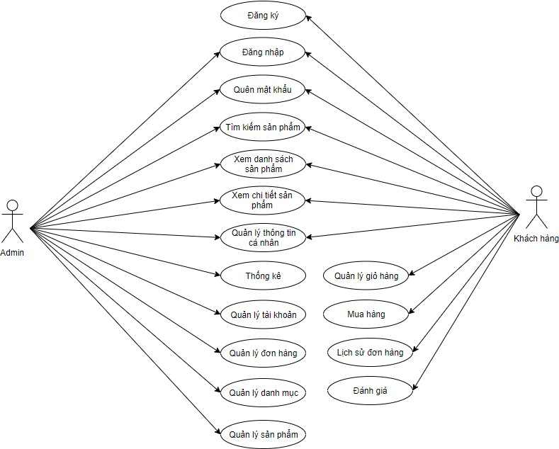
Use case analysis General use case

Figure 3.1: General use case diagram Describe the general use case by agent:
Agent Name | Use Cases
Customer | - Register  - Log  - Forgot Password  - Product Search  - View Product List  - View product details

- Management of Personal Information
- Cart Management
- Add to cart
- Order history
- Product Reviews
Admin | - Log  - Forgot Password  - Product Search  - View Product List  - View product details  - Management of Personal Information  - Statistics  - Account Management  - Order Management  - Portfolio Management  - Product Management
Table 3.1: Overview of use cases for each agent

Use case details
- Use Case Charts for Registration Functions
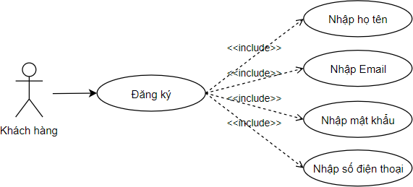
Figure 3.2: Use case registration function Description of the use case registration:

- Registration: To be able to order products, manage the information that customers must register, choose to register for the system that displays the user registration form, fill in the information in the form and then select confirm.
- Login function use case chart
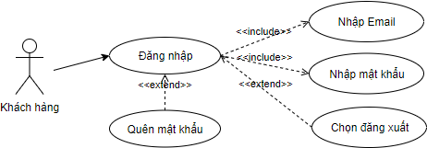

Figure 3.3: Use case of login function
- Login: after registration, the user will log in with the registered account.
- Forgot password: Users can enter their account information and email to re-issue the password
- Log out: after logging in, select Log out to log out of your account
- Product search function use case chart
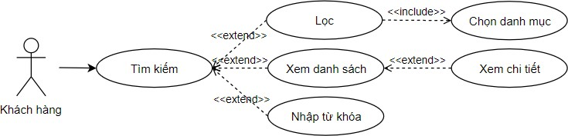

Figure 3.4: Use case of the product search function Description of the use case of the search function:
- Search by keyword: users search for products by name

- Search by category: Users search for products by product category on the navbar
- View product list: you can select a product category to view products in that category, or search for that type of product
- View product details: after displaying the product list or seeing the product you want to search, click to select it and the product detail page will appear
- Use case chart of personal information management functions
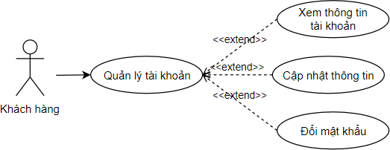

Figure 3.5: Use case of the personal information management function Description of the use case of the account information management function
- Management of personal information: Users can change personal information including full name, phone number, email, account.
- Change password: Users can change the password of the account
- Cart management function use case chart
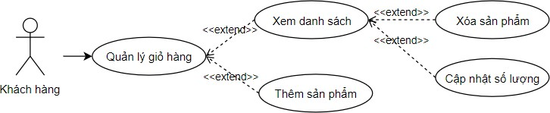

Figure 3.6: Use cases of the shopping cart management function Description of the use cases of the order management function:

- Add products to cart: customers select the product they like, then add the product to their cart
- Cart management: customers can update the quantity, delete the product, choose to place an order
- Purchase Function Use Case Chart

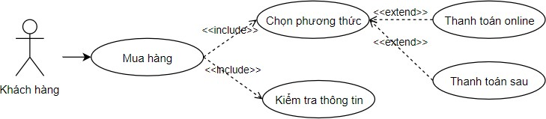

Figure 3.7: Use case of the purchase function Description of the use case of the order payment function:
- Purchase: after the user selects the product information to be purchased, they will select "order", then the system will display a payment form for the user to choose to pay, after selecting, the order will be confirmed
- Product Evaluation Function Use Case Chart
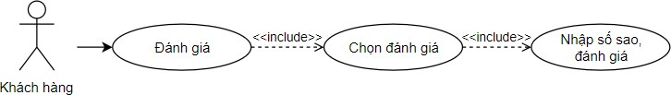

Figure 3.8: Use case of the product review function Description of the use case of the product review function:
- Order status: customers after ordering products can view the status and progress of the order.
- Product review: after the order is completed, the user can make a star review and comment on the order
- Statistical Function Use Case Chart

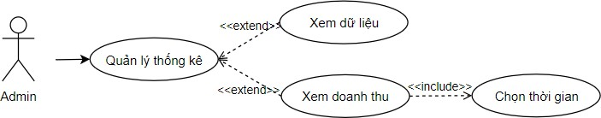

Figure 3.9: Use cases of the statistical function Description of the use case of the statistical function:
- Statistics - view data: when logging in to the admin's account, you will always access the statistics page, here there will be statistics on the number of users, the number of products on the web, the number of orders placed, the number of orders by status, the total revenue of the shop.
- Statistics - view revenue: Admin view your store's revenue by day of the month or month of the year by selecting the time.
- Catalog management function decay use case chart
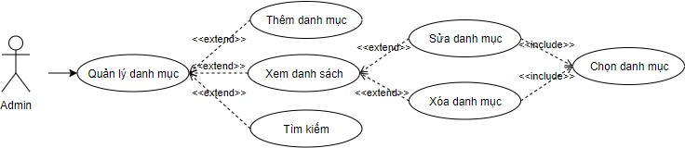

Figure 3.10: Use case decay of the portfolio management function Description of the decay use case of the account management function:
- Catalog management: admin selects to view the catalog list, performs additions, edits, and deletions of the catalog
- Product Management Function Use Case Chart

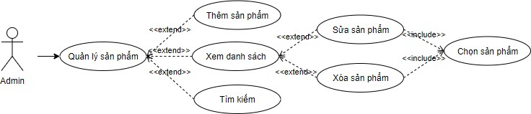
Figure 3.11: Use cases of the product management function Description of the use case of the product management function:
- Product management: admin chooses to view the product list, make additions, edits, and delete products
- Admin order management function use case chart
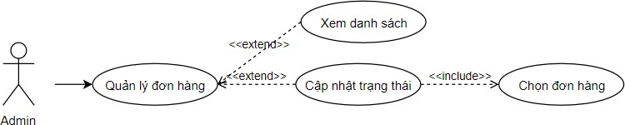

Figure 3.12: Use case of the admin order management function Description of the use case of the order management function:
- Order management: admin view the order list, select the order, then update the order status
- User Management Function Use Case Chart
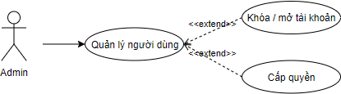

Figure 3.13: User management use cases Description of user management use cases:

User management: admin can grant admin permissions to customer accounts and can choose to lock or open accounts

Specification Analysis

Name use case | Register
Event Stream | Main Event Stream:  - The user visits the registration page on the website.  - The system displays the registration form with the fields to be filled in.  - Users fill in the required information such as full name, email, password to confirm the password  - Users tap the "Register" button to submit their registration information.  - The system checks the validity of registration information:  - If the information is invalid or the required field is missing, the system displays an error message and asks the user to re-enter it.  - If the information is valid, the system conducts registration verification.
Event Stream | Arising event stream:  - If the user already has an account on the system, the system displays an error message and asks the user to sign in instead of registering a new one.
Prerequisites | - The user has visited the registration page.  - The system is up and running and ready to process registration requests.
Post-conditions | - The user has completed the registration process and is redirected to the login page.  - The user's registration information is stored in the system and can be used

Table 3.2: Registration use case specifications

Name use case | Log
Event Stream | Main Event Stream:  - The user visits the login page on the website.  - The system displays a login form with fields to be filled in.  - The user fills in the required information: email and password  - Users tap the "Login" button to submit information.  - The system checks the validity of login credentials:  - If the information is invalid or the required field is missing, the system displays an error message and asks the user to re-enter it.  - If the information is valid, the system will proceed to verify the account.
Event Stream | Arising event stream:  - If the user uses an unregistered account, the message does not exist
Prerequisites | - The user has visited the login page.  - The system is up and running and ready to process registration requests.
Post-conditions | - The user has completed the login process and is redirected to the homepage.
Table 3.3: Login use case specifications

Name use case | Search
Event Stream | Main Event Stream:  - Select the search function  - Show a search box on your website  - The user enters the search keyword and presses the "Enter" button.  - The system processes database search and query requests.  - The system displays search results to users.  - Users view search results and interact with the results (for example, click a result to see details).
Event Stream | Generated event stream (no search results):  - The system shows blank as no matching search results.
Prerequisites | - The user has visited the homepage  - The system has a search interface and a search keyword input field.  - The system has a database that contains the data to be searched.
Post-conditions | - If there are search results, users can view the results and interact with them.  - If there are no search results, the results will be blank
Table 3.4: Specification of search use cases

Name use case | Management of Personal Information

Event Stream | Main Event Stream:  - The user visits the personal page.  - The system displays an information update interface with data fields (name, address, phone number, email).  - The user changes the information in the corresponding fields.  - The user clicks the "Save" button to update the information.  - The system validates information and updates new information in the database.  - The system displays a message confirming that the information has been updated successfully.
Event Stream | Arising event stream (invalid):  - The system checks information and detects invalid or missing information.  - The system displays an error message to the user, asking them to provide valid information or supplement the necessary information.
Prerequisites | - The user has visited the personal information update page.  - The system displays an interface that updates information with data fields.  - The system has a database containing the user's personal information.
Post-conditions | - The user's personal information has been successfully updated in the database.  - The system displays a confirmation message letting the user know that the information has been updated successfully.  - Users can view updated personal information.
Table 3.5: Specification of use cases for management of personal information

Name use case | Cart Management
Event Stream | Main Event Stream:  - The user visits the cart page  - Cart page display system  - The user selects the number of products and then selects Update  - The system updates the price of that product again  - Users can delete the product in the cart if they no longer want to buy it  - The system removes the product from the cart  - The system displays the total amount of all products in the cart
Event Stream | Sub-event stream:  - If there are no products in the cart, a blank list will appear
Prerequisites | - Logged-in users  - The user has added the product to the cart
Post-conditions | - The products in the cart are updated according to the user's actions
Table 3.6: Specification of cart management use cases

Name use case | Abate
Event Stream | Main Event Stream:  - The user selects "Order".  - Payment form display system

 | - The user selects the payment method and confirms the order
Arising event stream (account not found):
- If the user does not log in or register, they will be directed to the login or registration page.
- If the payment fails, the system displays an error message and asks the user to try again or change the payment method.
Prerequisites | - The user has selected the products and added them to the cart.  - The user is logged in or registered for an account.
Post-conditions | - Orders have been created in the system with the order information and the number of products sold has been updated.  - An order confirmation email has been sent to the user.  - The status of the number of products in stock has been updated after the order.
Table 3.7: Purchase use case specifications

Tên use case | Product Reviews
Event Stream | Main Event Stream:  - The user selects "Orders".  - The system displays a list of placed orders  - Users select the product they want to review and click on the "review" button  - The review page display system includes product information, stars, and reviews

- The user selects the number of stars and enters the review content, then confirms
- The system displays a success message
Recurring event stream (no review entry):
- If the user does not enter the review information, the system will notify the user that the review has not been entered for the user to complete
Prerequisites | - The user has selected the product to review.
Post-conditions | - The product is updated with review information  - Average number of stars for updated products
Table 3.8: Product evaluation use case specification

Event Stream | Main Event Stream:  - Admin access to the statistics page  - The system displays a statistics management page with categories and parameters taken from the database  - Admin select the date and month you want to see the total revenue  - The system displays the total revenue by selection
Prerequisites | - Logged in Admin  - Table data is already available
Post-conditions | - Updated Categories  - Total revenue displayed
Table 3.9: Statistical use case specifications

Tên use case | Portfolio Management

Event Stream | Main Event Stream:  - Admin access to category management  - Catalogue management page display  - Admin select the edit button and edit the catalog information  - Catalogue information update system  - Admin select the delete button  - The system for deleting that category  - Admin selects to add a category  - The system displays the form to fill in the category information  - The system displays a notification after completion
Event Stream | Arising event stream:  - If you delete a catalogue that contains products  - The notification system cannot be deleted
Prerequisites | - Logged in Admin  - Already in the catalog
Post-conditions | - Updated Categories
Table 3.10: Catalog management use case specification

Name use case | Product Management

Event Stream | Main Event Stream:  - Admin access to product management.  - The system displays the product management page.  - Admin select the edit button and edit the product information.  - The system updates product information.  - Admin select the delete button.  - The system deletes that product.  - Admin selects to add a new product.  - The system displays a form to fill in product information.  - Admin fill in the product information and select Save.  - The system saves the product and displays a notification after completion.
Event Stream | Arising event stream:  - If you delete a product that has an associated order:  - The notification system can't delete the product because there is an order involved.
Prerequisites | - Admin is logged in.  - The product is already in the system.
Post-conditions | - The product is updated or deleted successfully.
Table 3.11: Product management use case specification

Name use case | Order Management

Event Stream | Main Event Stream:  - Admin access to order management.  - The system displays a list of orders.  - Admin select an order to view details.  - The system displays the details of the order.  - Admin selects the edit button and updates the order status.  - The system updates the status of the order.  - Admin select the Delete Order button.  - The system deletes the order.  - Admins can filter orders by status or date.  - The system displays orders according to the selected filter.
Event Stream | Arising event stream:  - If you delete an order that has already been delivered:  - The system notifies that the ordered order cannot be deleted.
Prerequisites | - Admin is logged in.  - There is already an order in the system.
Post-conditions | - The order is updated in status or successfully deleted.
Table 3.12: Specification of use cases for order management

Website Design

Backend Design

Databases
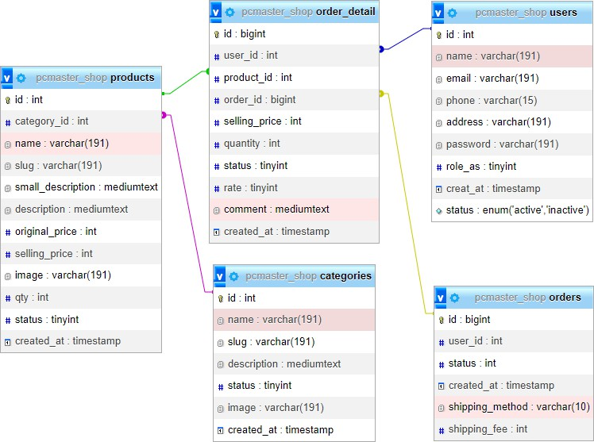

Figure 3.14: Database design
Database description
Table 3.13: Table of Categories

Information Fields | Data Type | Describe
id | int(11) | Category IDs
name | varchar(191) | Category Name
Slug | varchar(191) | Unsigned name of the catalogue

description | Medium text | Description of Category
Status | Tinyint(4) | The status of the catalog
image | varchar(191) | Portfolio Photos
created_at | timestamp | time

Table 3.14: Orders table

Information Fields | Data Type | Describe
id | bigint(20) | The ID of the order
user_id | int(11) | User ID
status | int(11) | Order Status
created_at | timestamp | time
shipping_method | varchar(10) | Shipping Type
shipping_fee | int | Shipping amount

Table 3.15: Table oder_detail

Information Fields | Data Type | Describe
id | bigint(20) | Category IDs
user_id | int(11) | User ID
product_id | int(11) | Product ID
order_id | bigint(20) | The ID of the order

selling_price | int(11) | Price after discount
quantity | int(11) | Order quantity
status | tinyint(4) | Status of the order
rate | tinyint(4) | Discount Percentage
comment | Medium text | comment
created_at | timestamp | time

Table 3.16: product table

Information Fields | Data Type | Describe
id | int(11) | Product ID
category_id | int(11) | Category IDs
product_id | int(11) | Product ID
name | varchar(191) | Product Name
slug | varchar(191) | Unmarked Product Name
small_description | Medium text | Short Description
description | Medium text | Full description
original_price | int(11) | Original price
selling_price | int(11) | Sale Price
image | varchar(191) | Product Photos

qty | int(11) | Number of products available
status | tinyint(4) | Product Status
created_at | timestamp | Product Creation Time

Table 3.17: user table

Information Fields | Data Type | Describe
id | int(11) | User ID
name | varchar(191) | Username
email | varchar(191) | User Email
phone | varchar(15) | User Phone Number
address | varchar(191) | User Address
password | varchar(191) | User Password
role_as | Tinyint(4) | Decentralization
creat_at | timestamp | Creation time
Status | Enum | Account Status

Analyze the class diagram
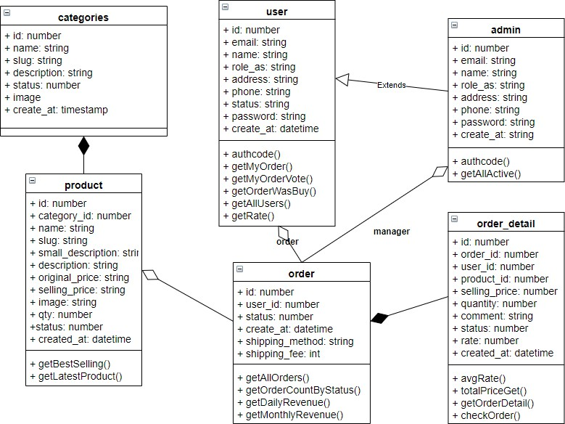
Figure 3.15: Layer Diagram

ERD Diagram Analysis
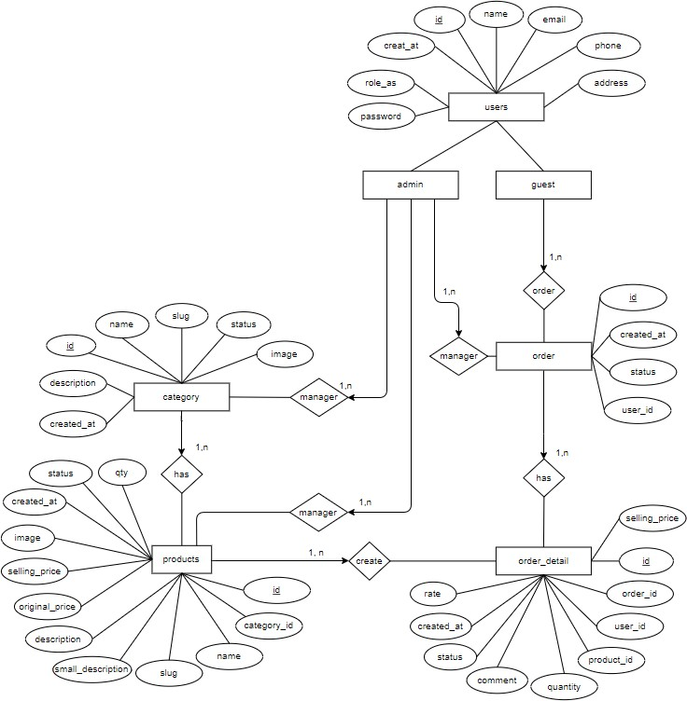

Figure 3.16: ERD Diagram

Frontend design
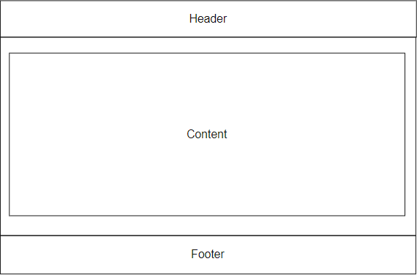

Figure 3.17: Homepage interface design
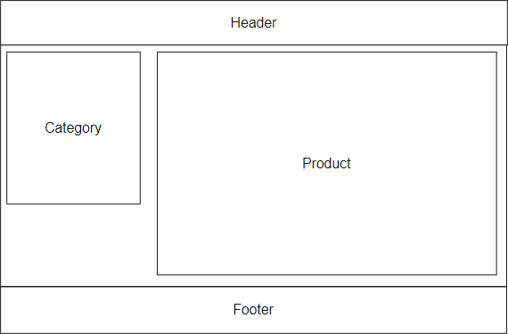

Figure 3.18: Catalog page interface design
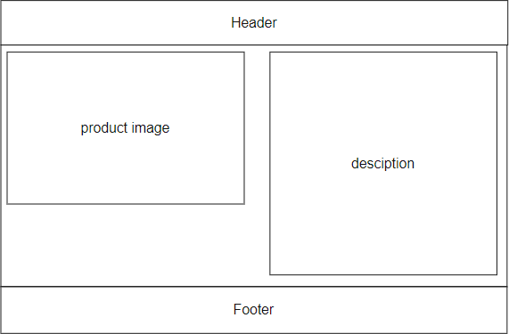

Figure 3.19: Product page interface design
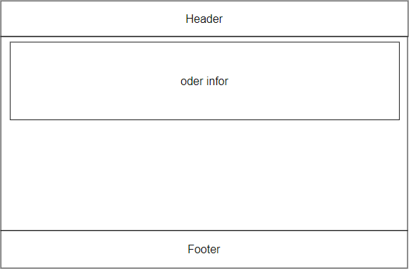

Figure 3.20: Cart page interface design

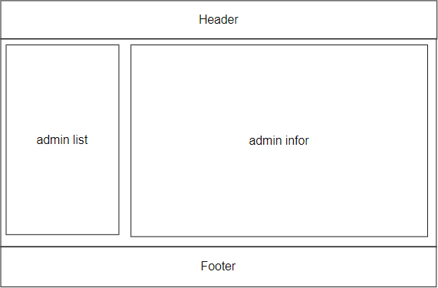

Figure 3.21: Designing the admin page interface

Activity Chart Design
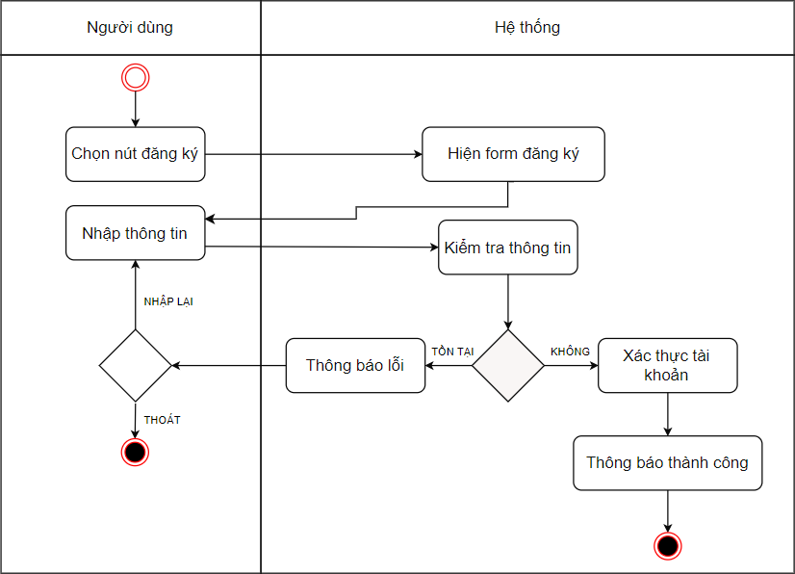

Figure 3.22: Chart of registration activities
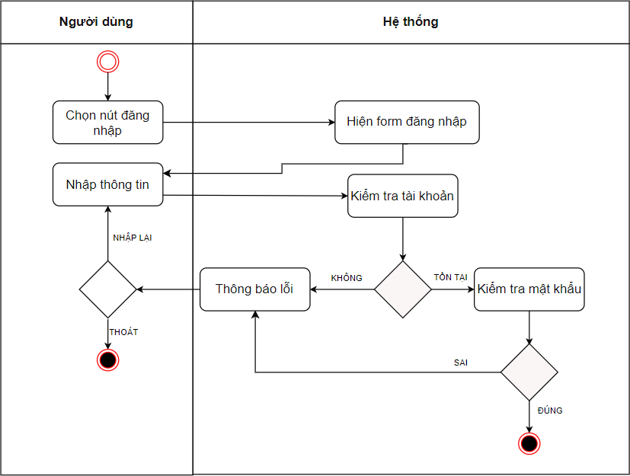
Figure 3.23: Login activity graph
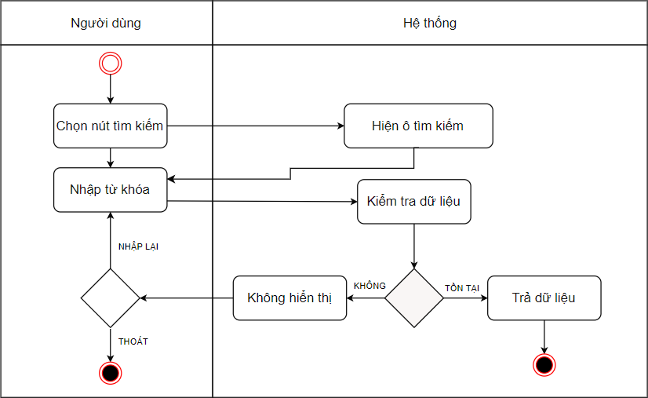
Figure 3.24: Graph of search activity

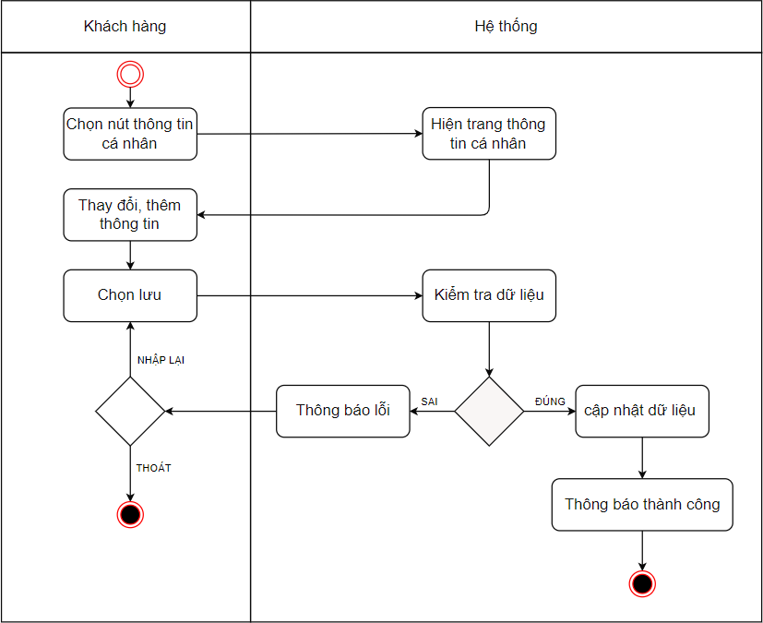

Figure 3.25: Chart of personal information management activities
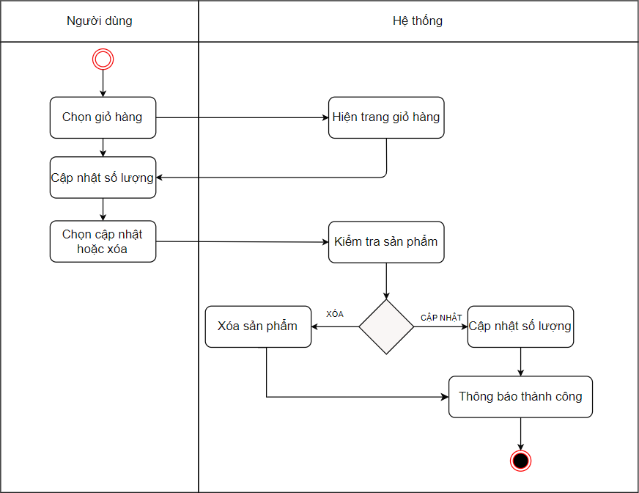

Figure 3.26: Cart management activity chart
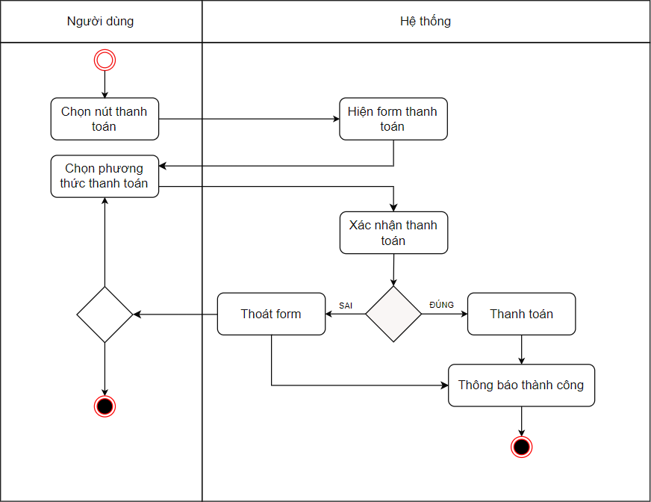
Figure 3.27: Purchasing activity chart
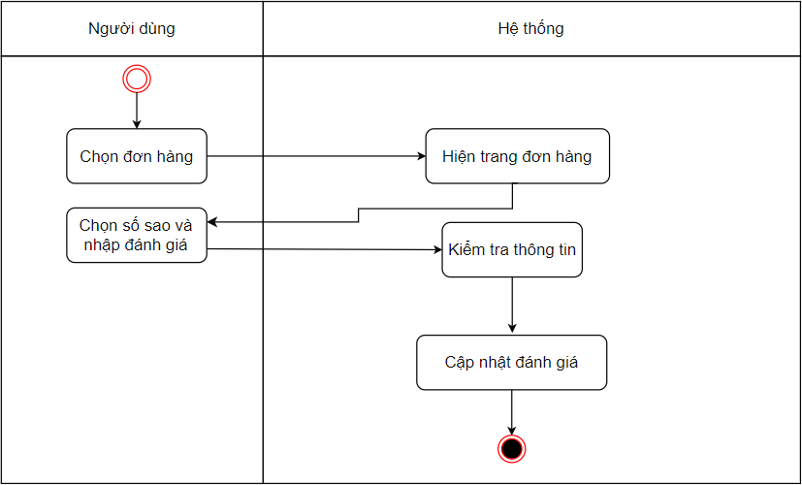
Figure 3.28: Product evaluation activity chart

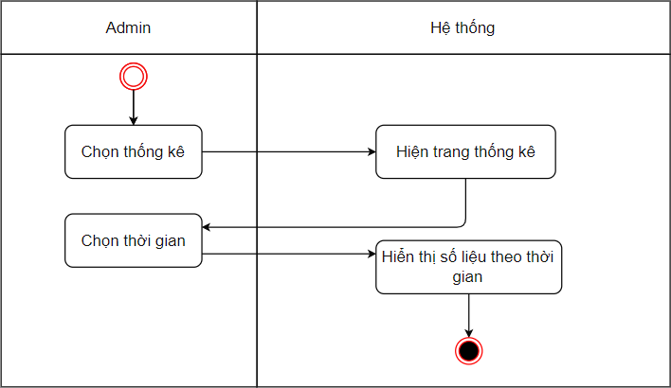
Figure 3.29: Chart of statistical activities
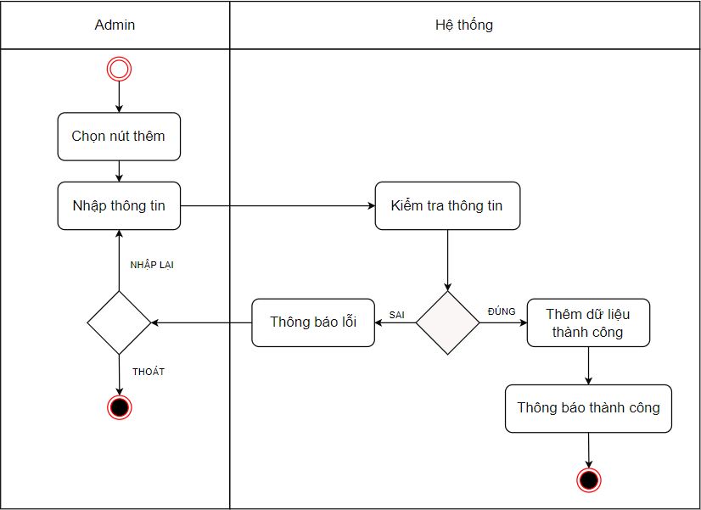
Figure 3.30: Data addition activity chart

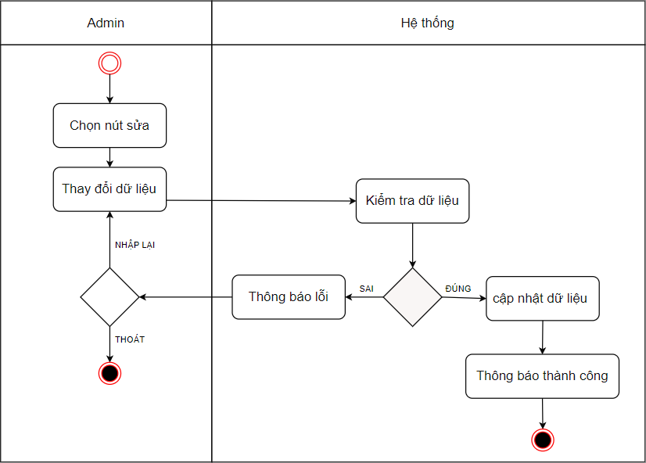
Figure 3.31: Data correction activity chart
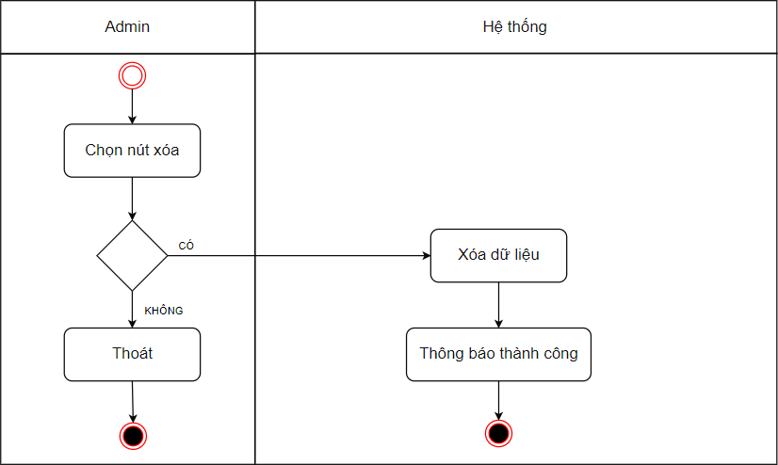
Figure 3.32: Data Deletion Activity Chart

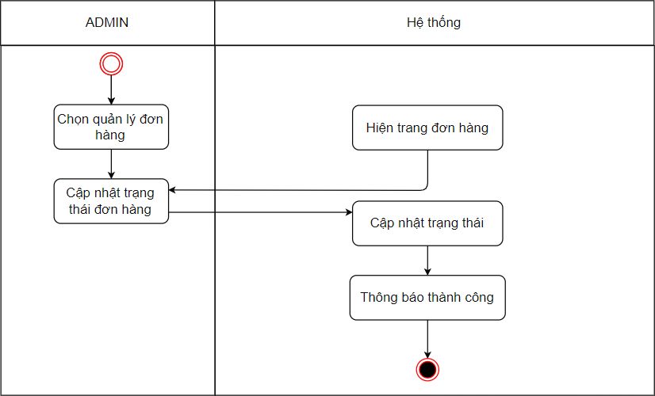
Figure 3.33: Chart of order management activities

Sequential chart design
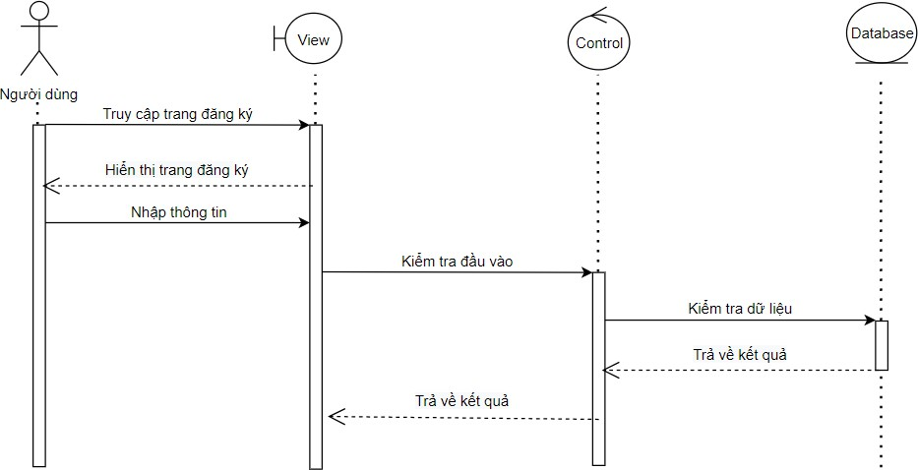

Figure 3.34: Sequential registration chart

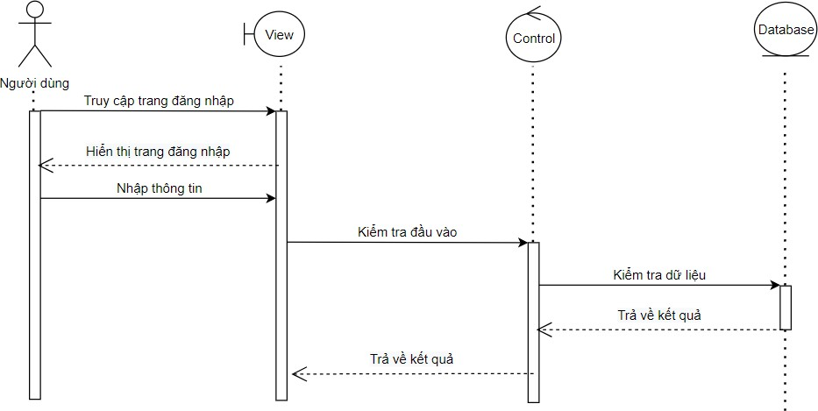

Figure 3.35: Login sequential chart
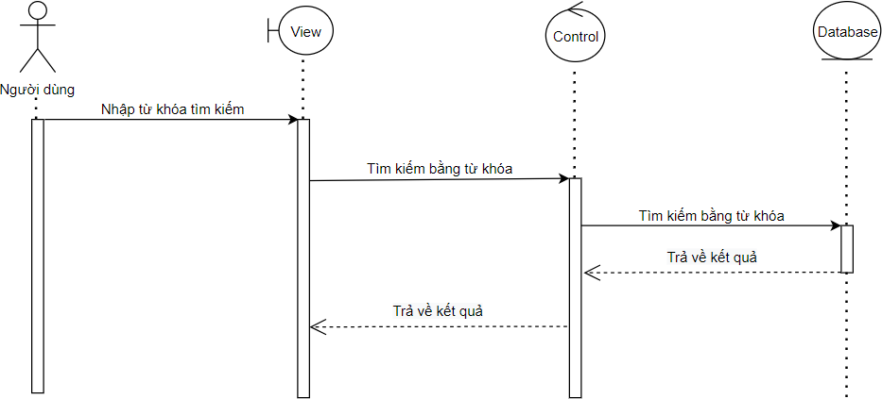

Figure 3.36: Search sequential chart
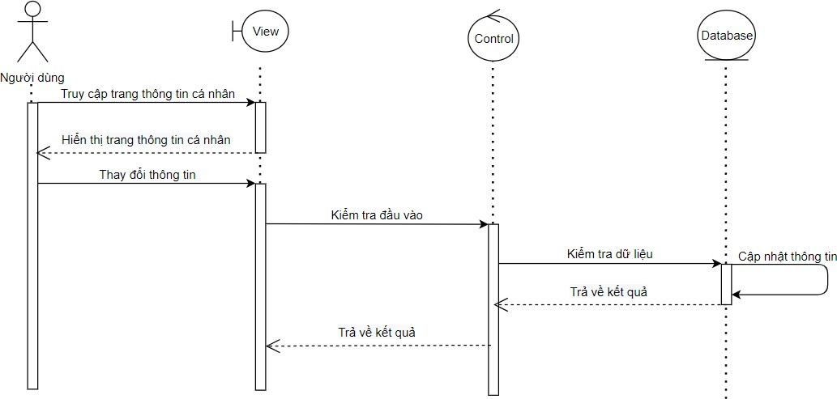

Figure 3.37: Sequential chart of personal information management
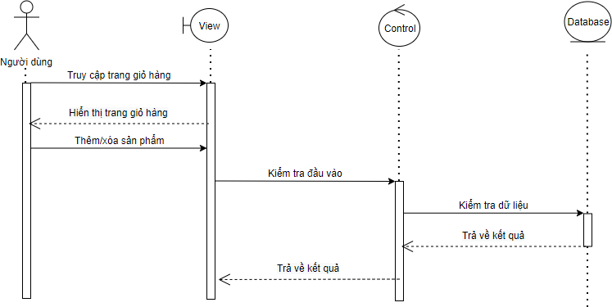

Figure 3.38: Cart management sequential chart
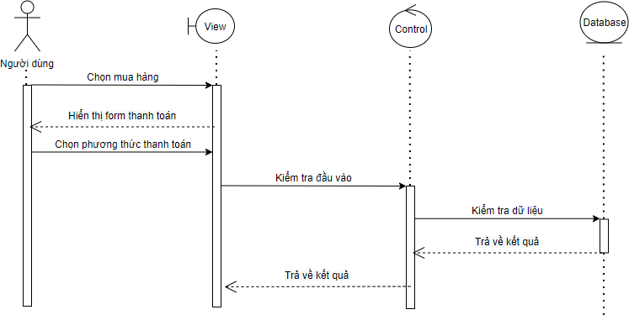

Figure 3.39: Purchase sequential chart

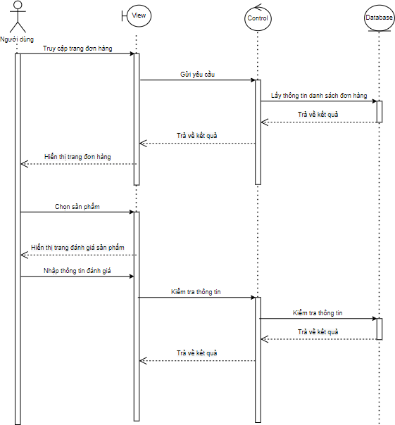

Figure 3.40: Sequential chart of product evaluation
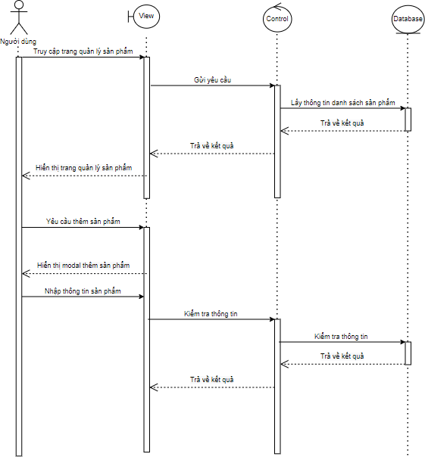
Figure 3.41: Sequential chart of adding products

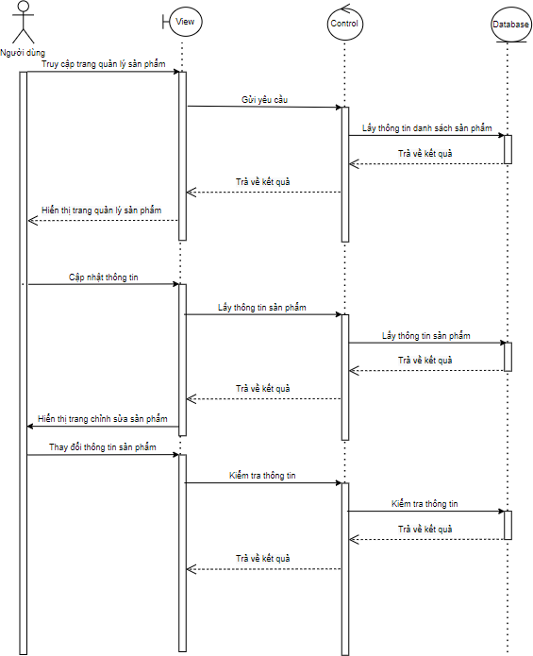
Figure 3.42: Sequential chart of product repairs

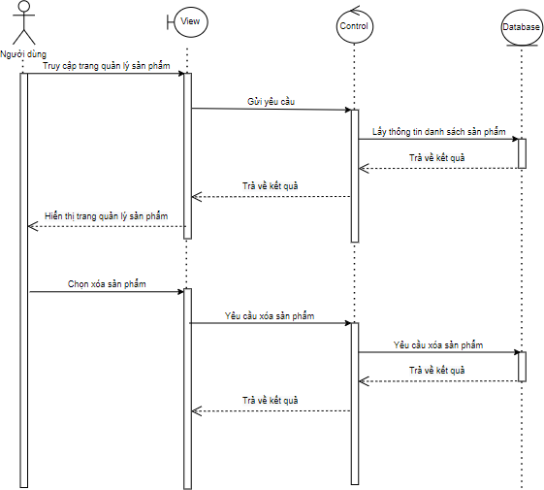

Figure 3.43: Sequential chart of product deletions
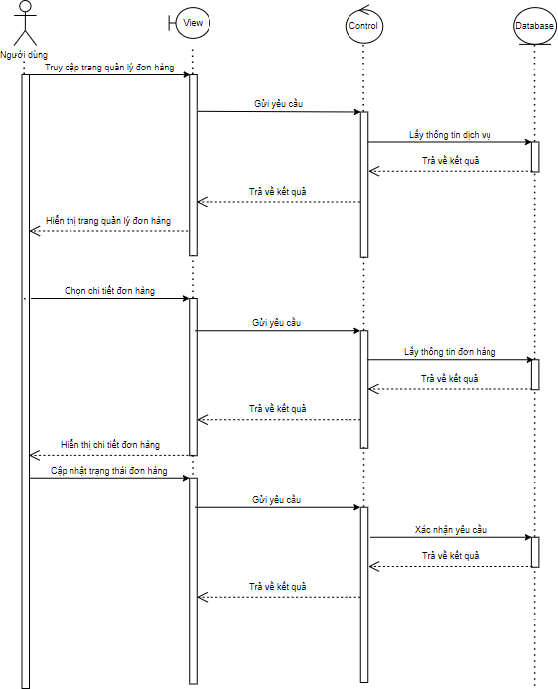
Figure 3.44: Order management sequential chart

Conclude
In chapter III, I analyzed the agents in the system, thereby identifying the operations for each object. Based on the analyzed operations to design appropriate functional use cases, accompanied by functional specifications, sequential chart design, activity charts, class diagrams, ERD diagrams. Then there is the design of the backend system, the frontend interface.

CHAPTER 4. SYSTEM INSTALLATION AND TESTING

Install the XAMPP Installation Program
    - Download XAMPP: Access (https:// www.apachefriends.org/index.html) and
Download the XAMPP version that is compatible with your operating system (Windows, macOS, Linux).
    - XAMPP Installation:
    - Run the XAMPP installation file.
    - During the installation process, make sure to select the necessary components: Apache (web server), MySQL (database), PHP, and phpMyAdmin.
    - Once the installation is complete, open the XAMPP Control Panel and start Apache and MySQL.

Setting up a PHP project
    - Create a project folder:
    - Open the 'htdocs' folder in the XAMPP installation folder (usually
'C:\xampp\htdocs' on Windows).
    - Create a new folder for the project.
    - Access the app via a browser:
    - Open a browser and enter the address: 'http://localhost/vinamotor/'.

Configuring MySQL with phpMyAdmin
    - Go to phpMyAdmin:
    - Go to the 'http://localhost/phpmyadmin/' address on your browser to open phpMyAdmin.
    - Create a database:
    - In phpMyAdmin, select the Databases tab.
    - Create a new database for the 'vinamotor' project.
    - Create a table in the database:

    - After creating a database, click on it and create a table to store the data

Connecting PHP to MySQL
In the PHP file, vinamotor needs to connect to the MySQL database.
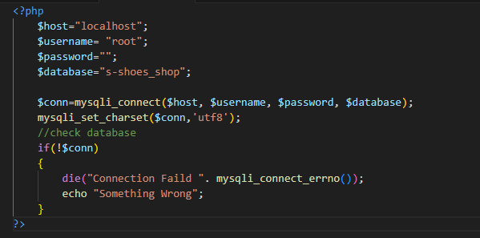

Run the app
After successfully establishing the connection, vinamotor can start writing functions such as registering, logging in, adding products to the cart, etc. Make sure vinamotor checks its code after making changes by accessing the 'http://localhost/vinamotor/'.
'php.ini' configuration (if needed)
    - If you need to change the PHP settings, vinamotor can edit the
'php.ini' in the XAMPP folder (usually 'C:\xampp\php\php.ini').
    - For example, to enable error display during development, find the line
'display_errors = Off' and change it to 'display_errors = On'.
    - Restart Apache and MySQL (if needed)
    - After making changes in the configuration file or project structure, be sure to restart Apache and MySQL from the XAMPP Control Panel to make sure the changes take effect.
    - After completing these steps, vinamotor will have a PHP, MySQL development environment with XAMPP ready to develop its web application.

Program Testing
Table 4.3: Testing User Functionality

Function | Input Value | Conclusion | Result
See name book product | Not | Show Product List | Reach
Search | Word lock search | name book Assets products containing keywords | Reach
Detailed Product Description | Product Name | Product Details | Reach
Register | They name email, password | Successful Registration | Reach
Log | Accounts, passwords | Successfully accessing the account | Reach
Order Products | product | Assets dye get successfully set | Reach
Add data | Enter Lack of information | Error Messages | Reach
Edit data | Data changes | Added data | Reach
Clear data | Press Delete Data | Deleted data | Reach

CHAPTER 5. CONCLUDE

Interface

Figure 5.1: Registration interface
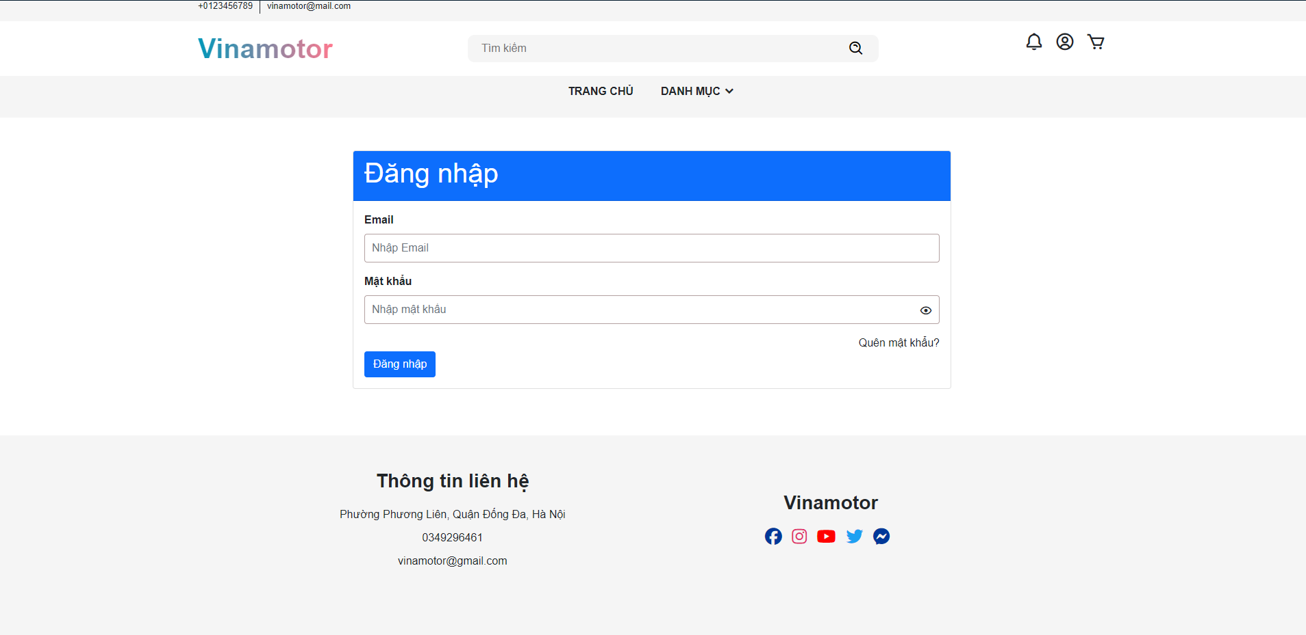
Figure 5.2: Login page interface
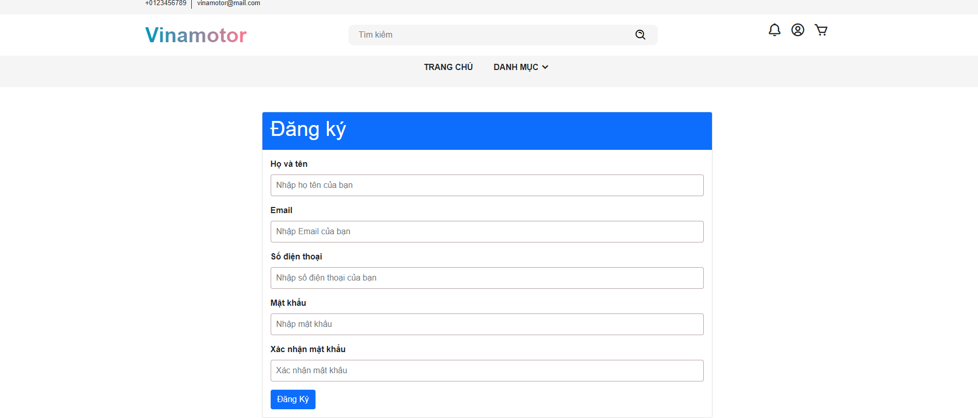

Figure 5.3: Homepage interface

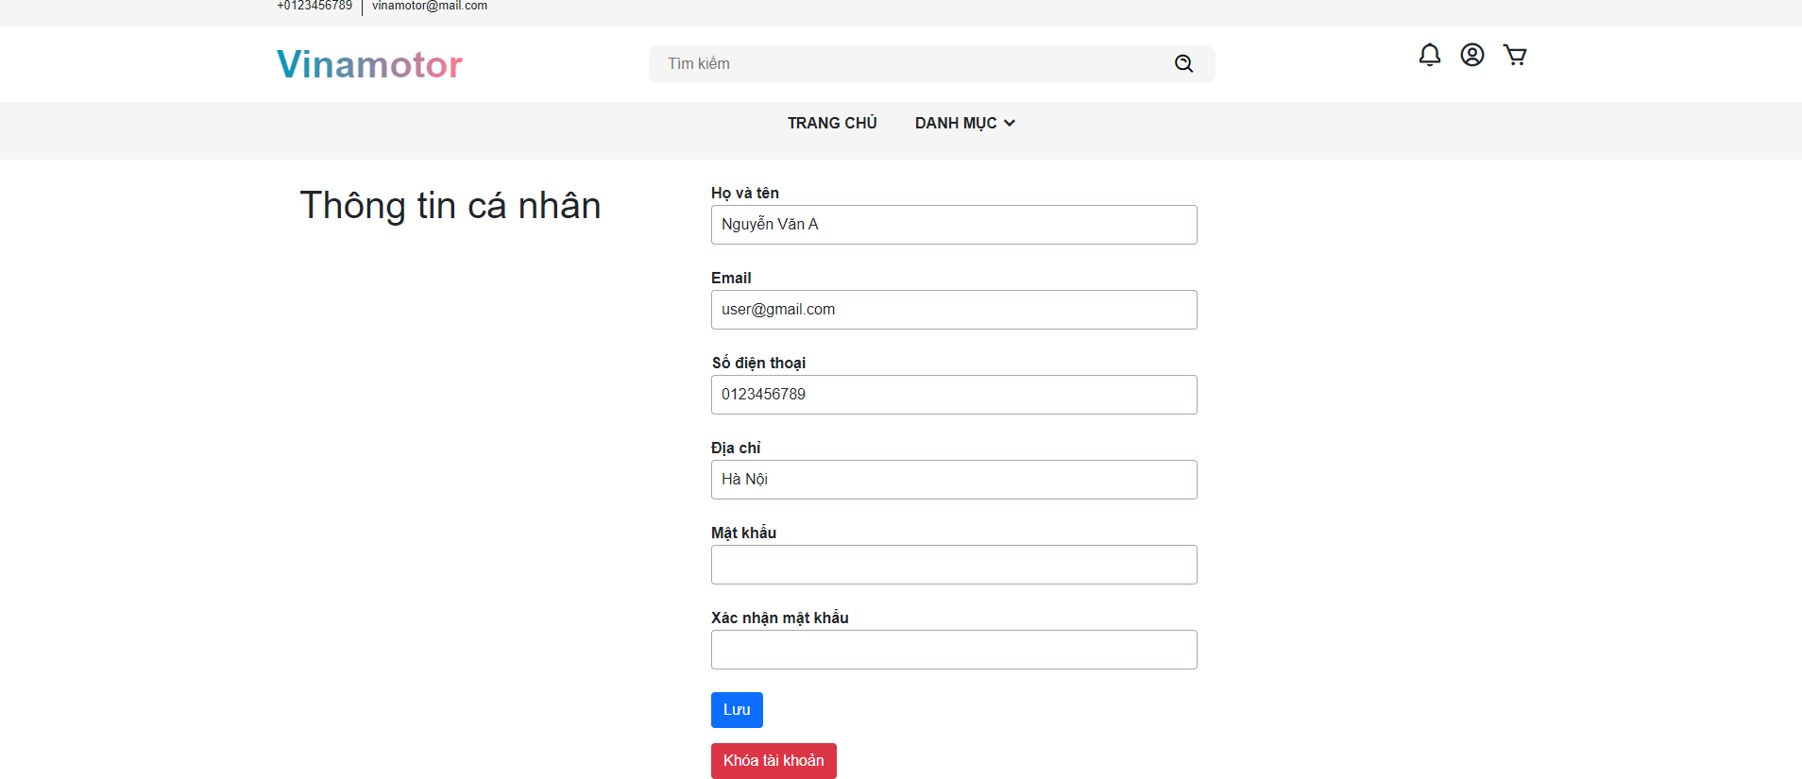
Figure 5.4: Interface of the personal information management page

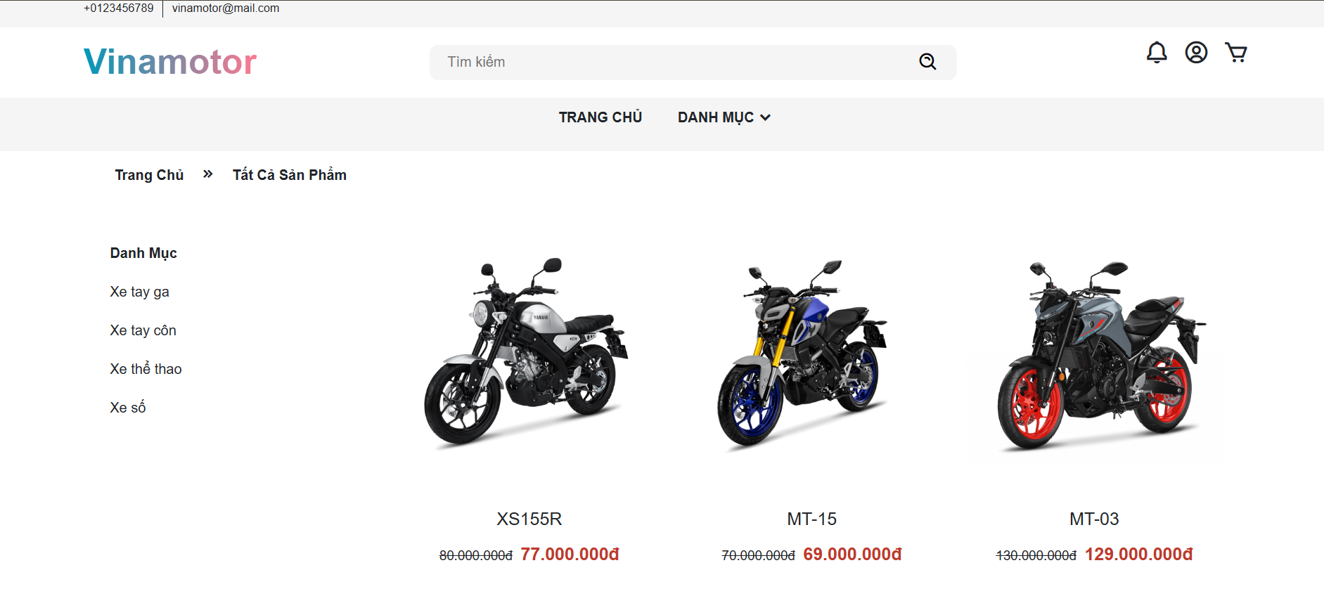
Figure 5.5: Product page interface by category


Figure 5.6: Product detail page interface
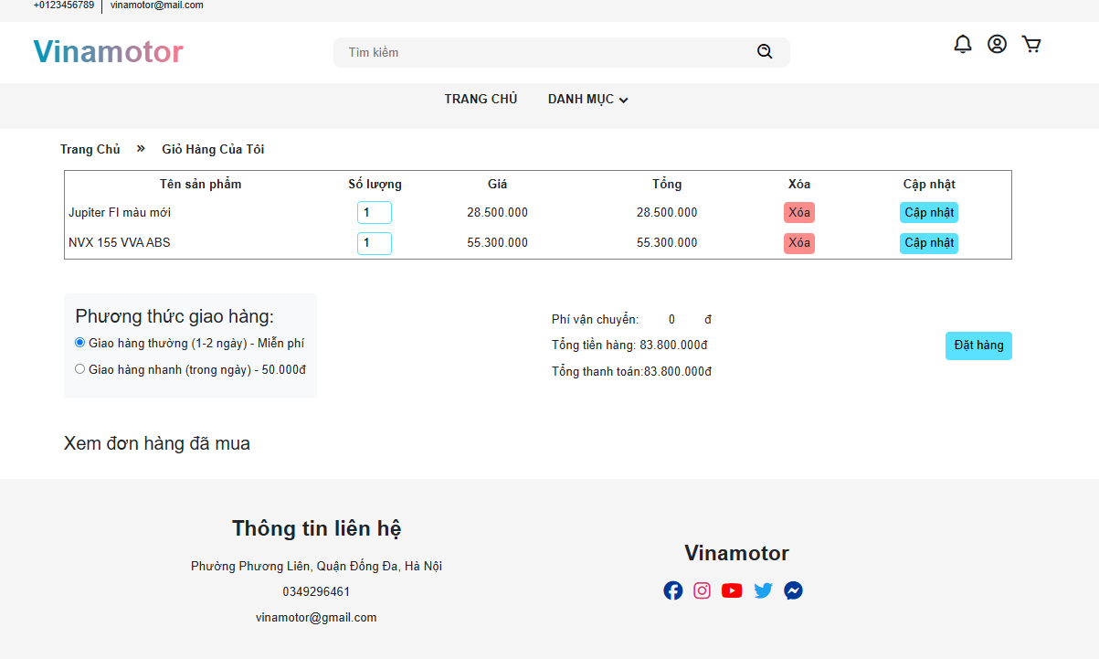
Figure 5.7: Cart page interface

Figure 5.8: Purchase interface
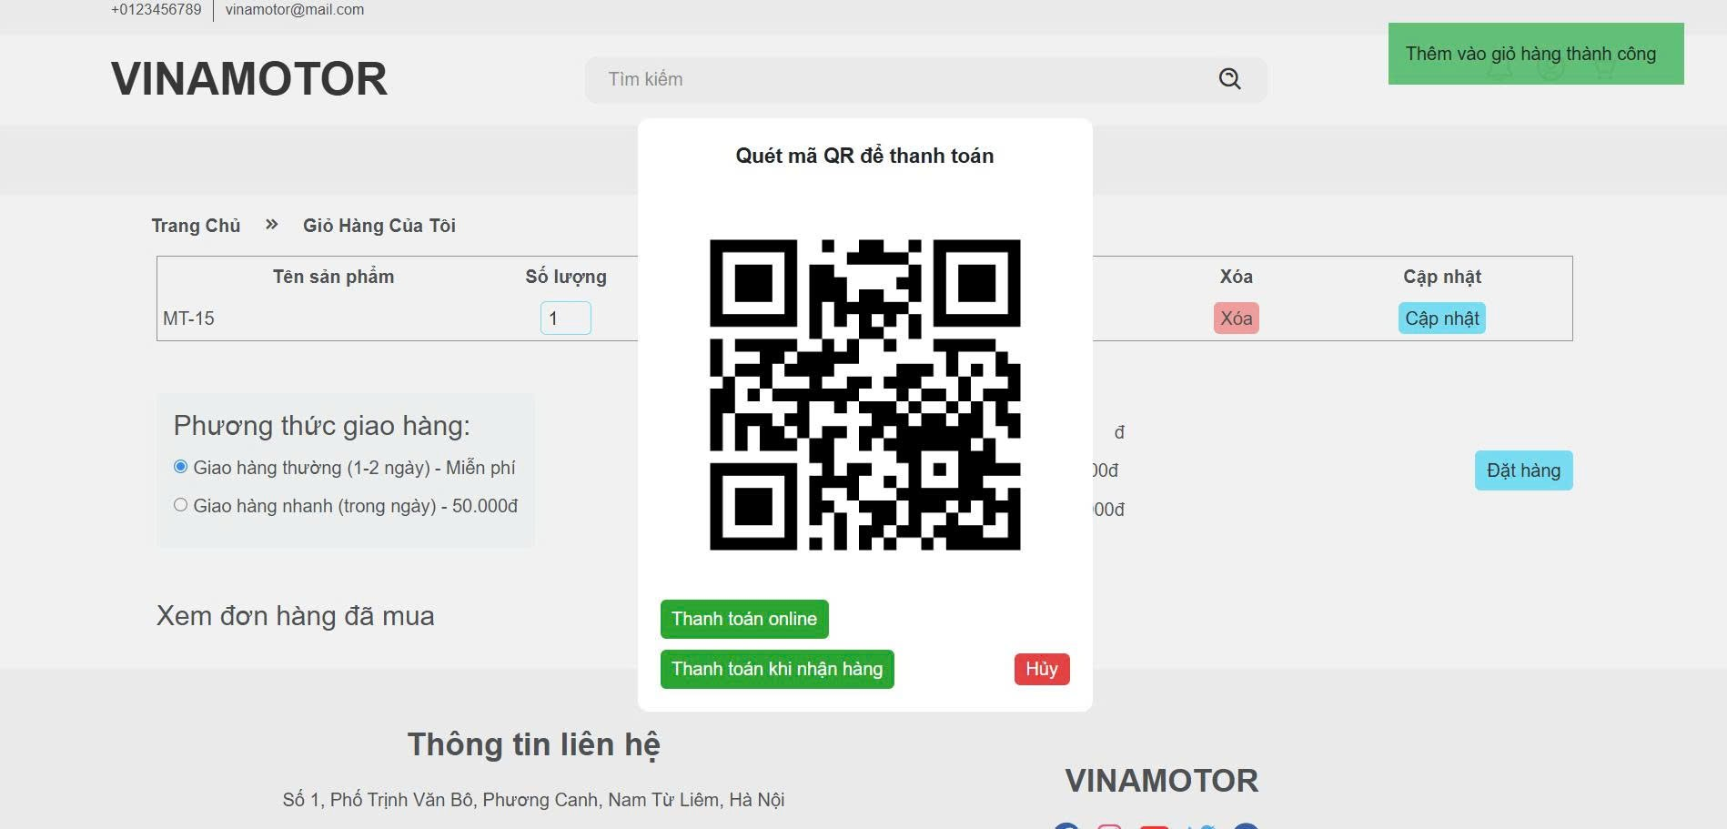
Figure 5.9: Order page interface

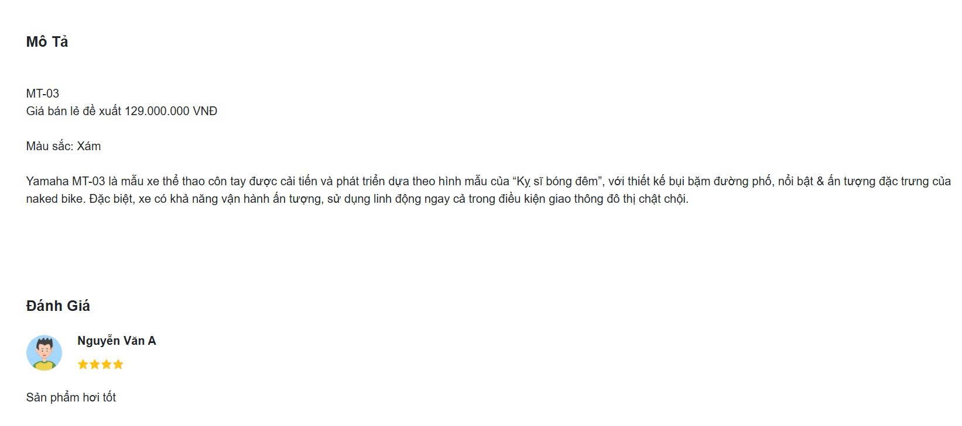
Figure 5.10: Review page interface

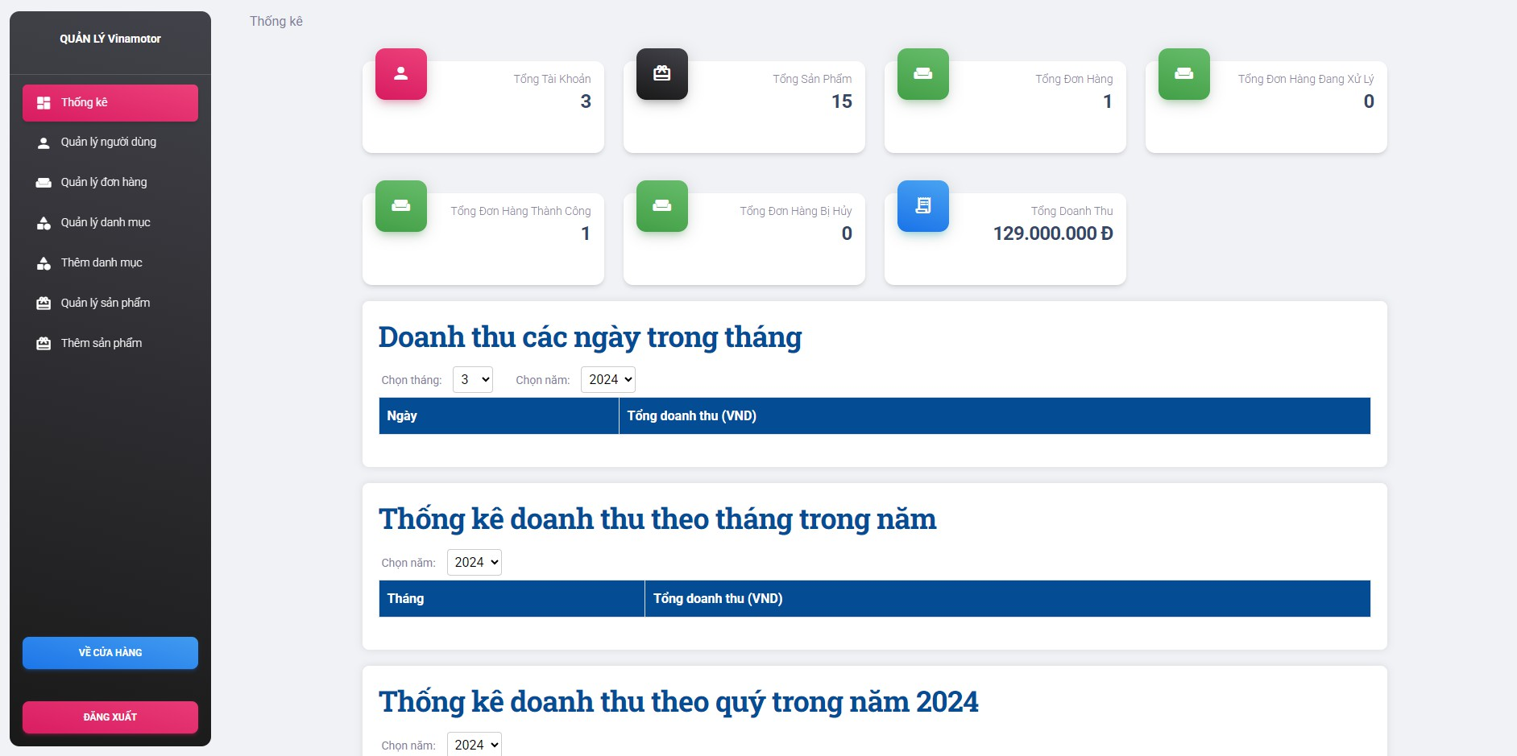
Figure 5.11: Statistics page interface
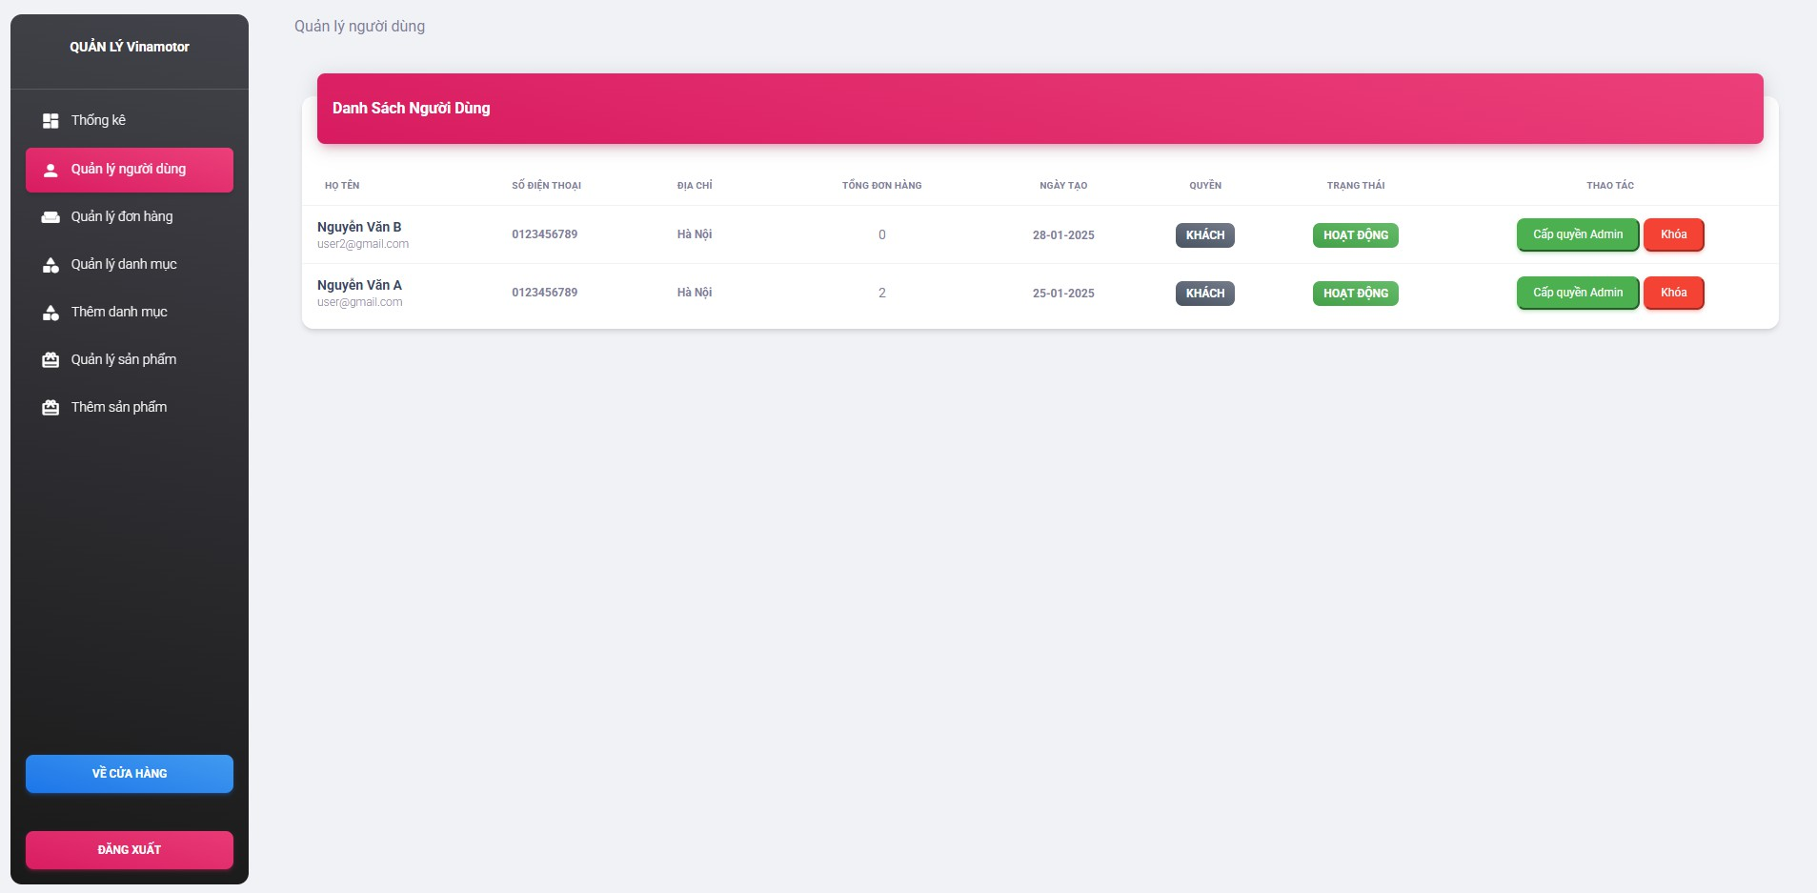
Figure 5.12: Account management page interface

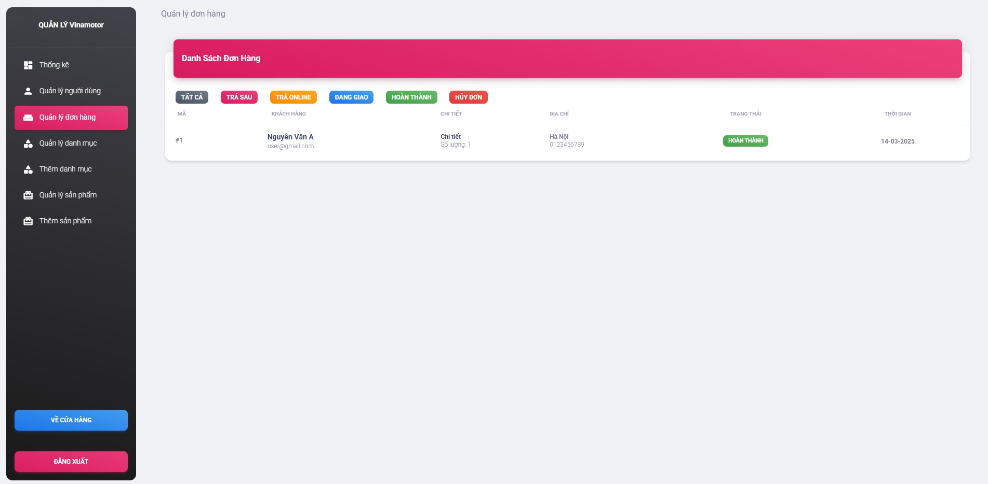
Figure 5.13: Order management page interface
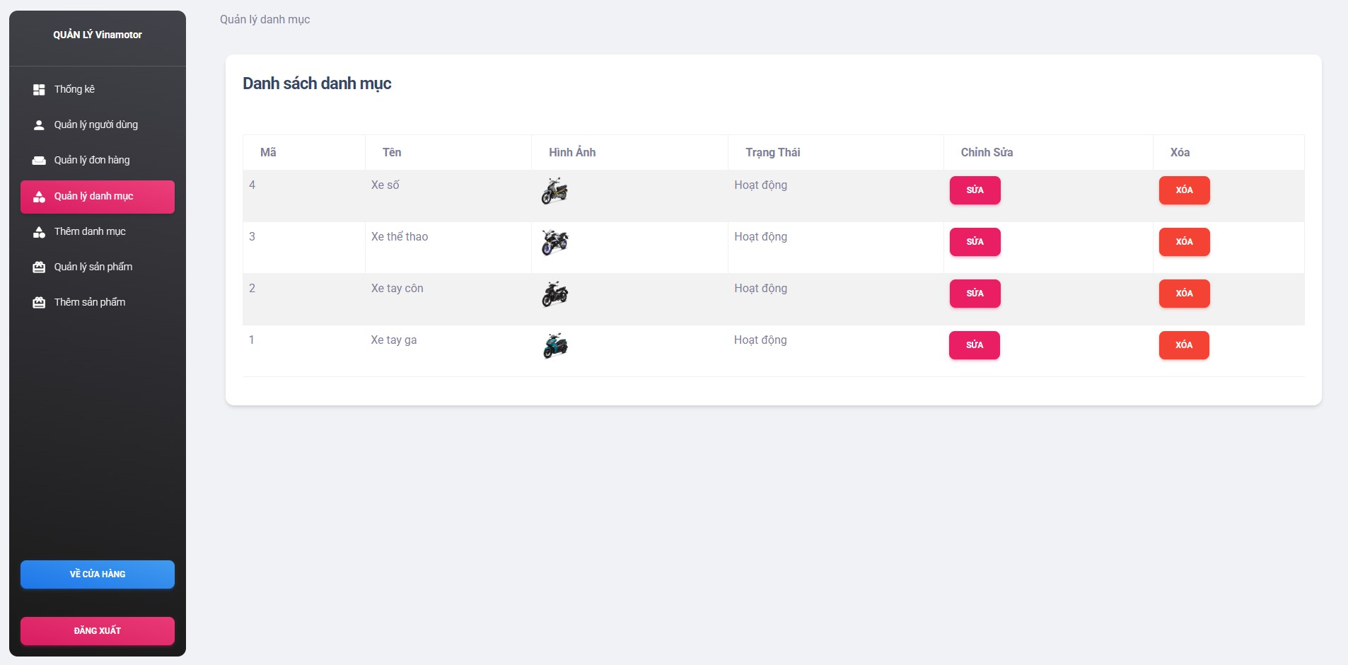
Figure 5.14: Catalog management page interface

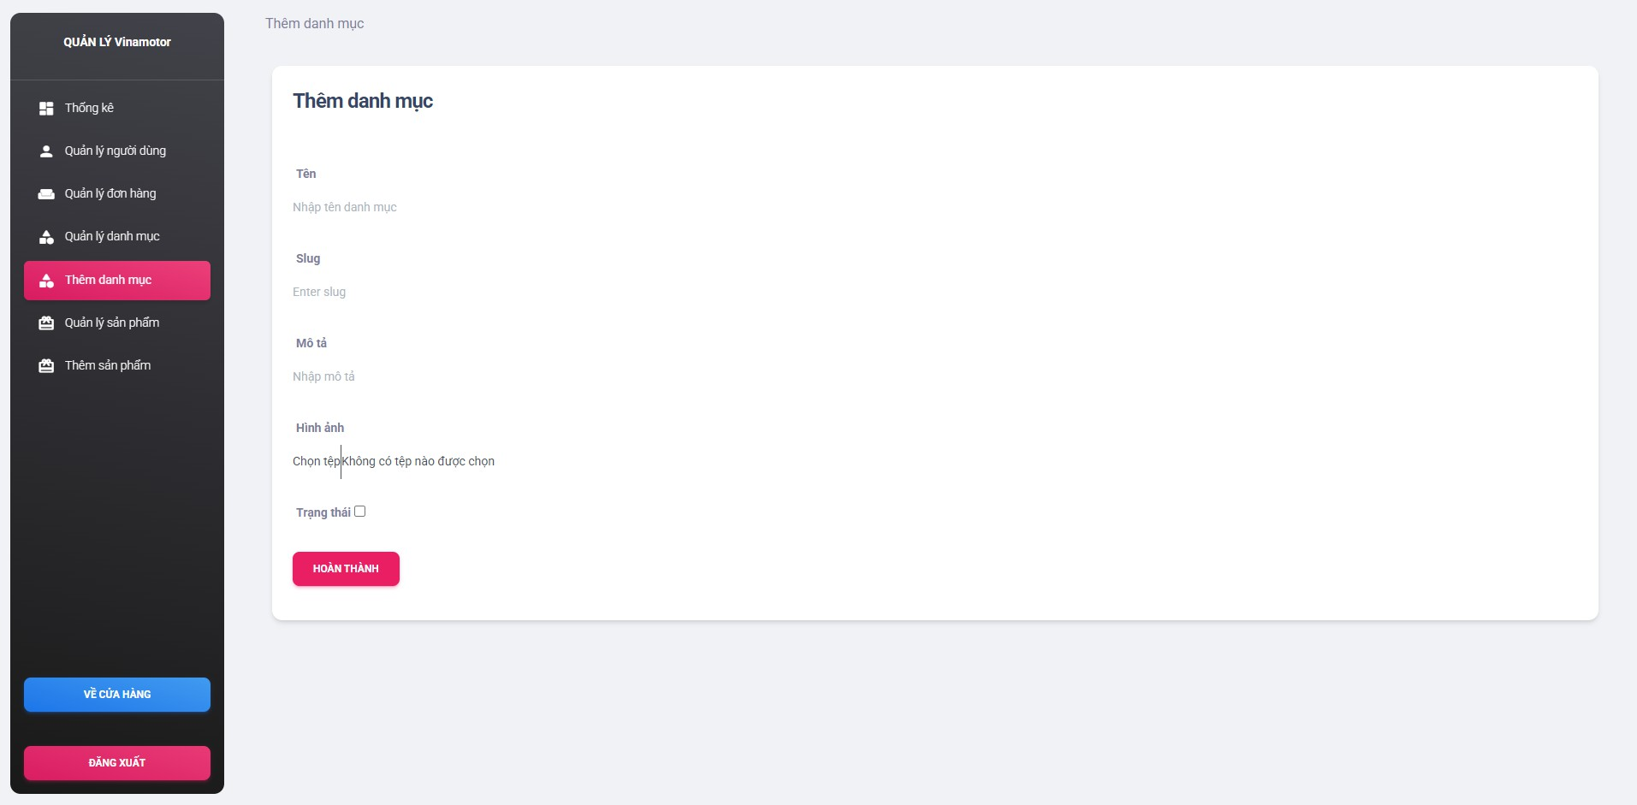
Figure 5.15: Page interface for adding categories
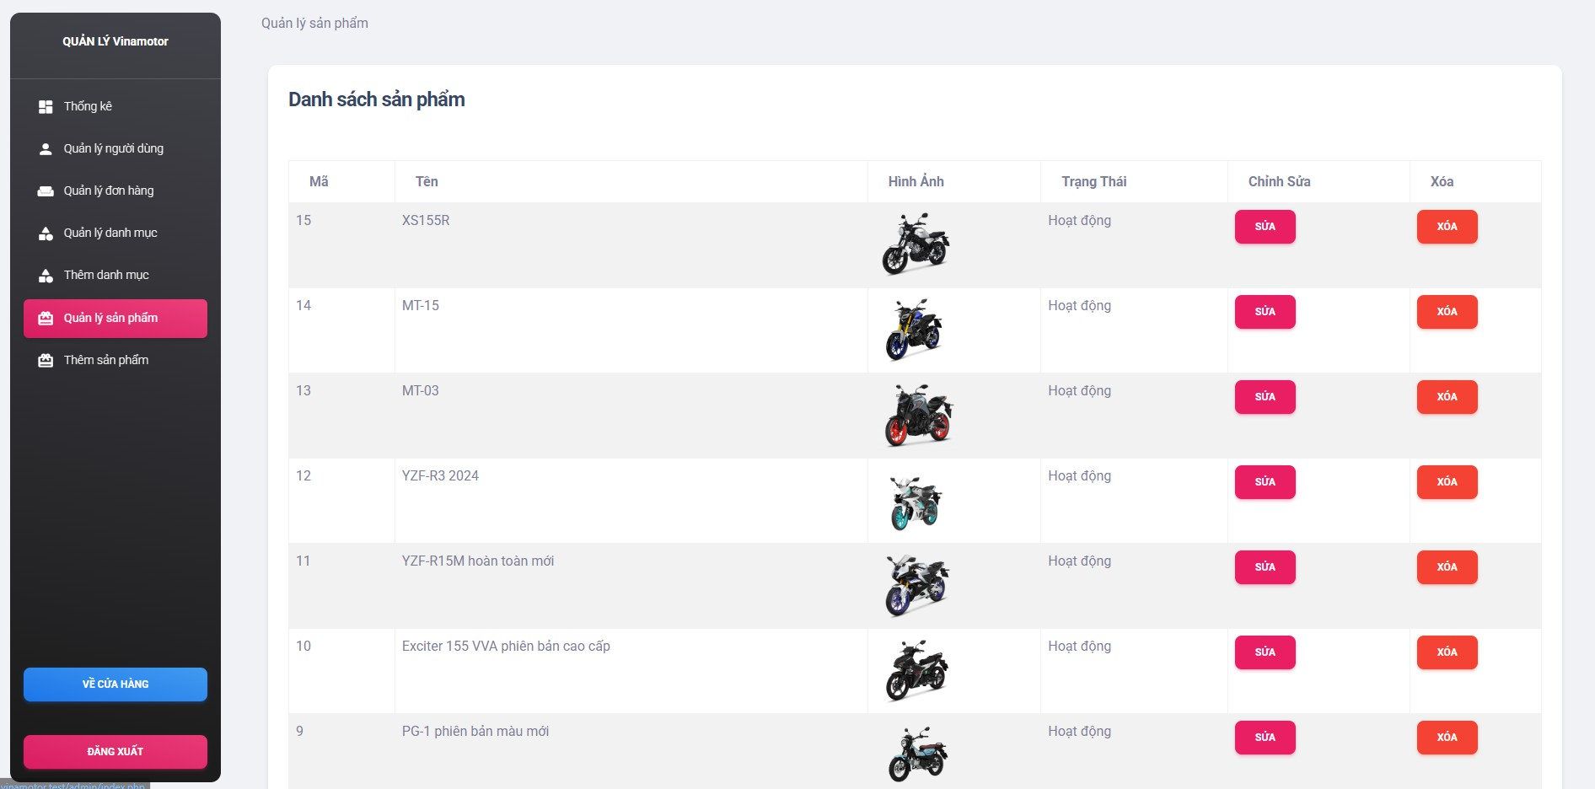
Figure 5.16: Product management page interface

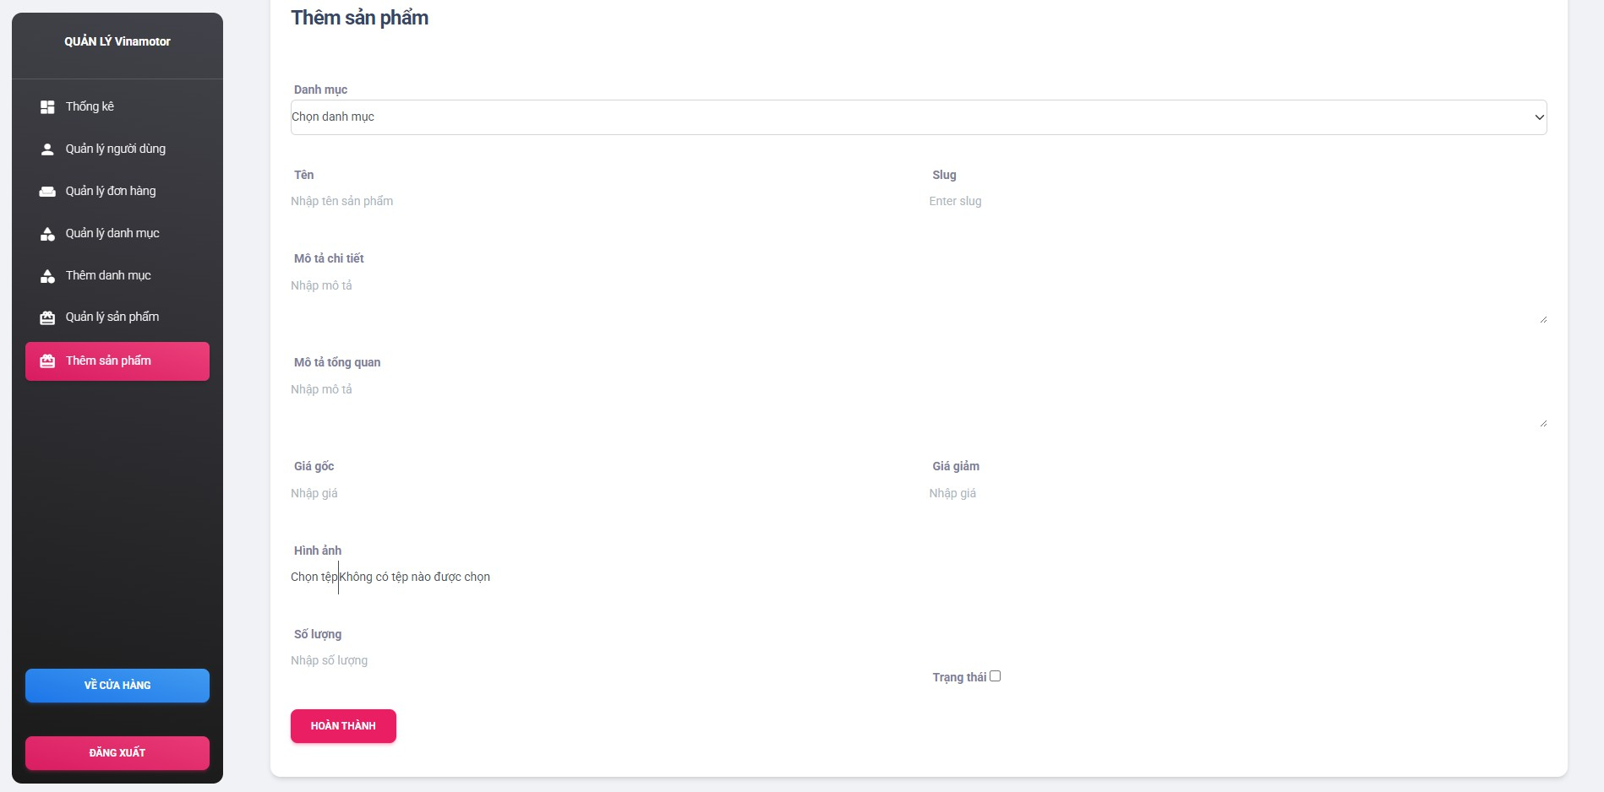
Figure 5.17: Product add-on page interface

Results Achieved
Attractive interface design: Create an intuitive and attractive interface for the software to sell motorcycles for Vinamotor stores on the web. This interface needs to ensure user-friendliness and ease of use
Successfully implement the online ordering feature for users. This includes the ability to search for products, view categories, select products, add to cart.
Order management: Build an effective order management system, allowing restaurants to receive and process orders from customers easily. This includes order confirmation, order status management, and notifications to customers about the status of their orders.

Development direction
Integrate location features: Integrate location features so that customers can easily search for stores near them and place orders from the most convenient location.
Security and privacy: Ensure that customer information is kept secure and privacy-compliant. This ensures that

Customer's personal information and payment information are not leaked or misused.
Integrate social media channels: Integrate social media channels that allow customers to share their experiences and reviews with others, increasing the reach and promotion of the store.
Optimize speed and performance: Ensure that your website works quickly and smoothly, and limit page load times to provide the best user experience

Conclude
The project to build a web-based motorcycle sales software for Vinamotor stores has achieved important goals, including designing an attractive interface, successfully implementing the online ordering feature, and building an effective order management system. These results contribute to improving the user experience and supporting easier operation management. However, there is still a lot of potential for future development such as location integration, ensuring security, expanding social media channels, and optimizing performance to improve service quality and competition.

REFERENCES
- : Web Programming Textbook - Author: Tran Dinh Que, Vietnam National University Press, Ho Chi Minh City. Ho Chi Minh City, 2020.
- : PHP and MySQL Web Development - Tác giả: Luke Welling, Laura Thomson, Pearson Education, 2021.
- : Bootstrap: Responsive Web Development - Tác giả: Jake Spurlock, O'Reilly Media, 2020.
- : Professional JavaScript for Web Developers - Tác giả: Nicholas C. Zakas, Wrox Press, 2019.
- : Database System Concepts - Tác giả: Abraham Silberschatz, Henry F. Korth, S. Sudarshan, McGraw-Hill, 2019.
- : W3Schools - A Guide to PHP, MySQL, Bootstrap, and JavaScript: https://www.w3schools.com
- : Stack Overflow - Background block pass change sutra consider establish submit: https://stackoverflow.com
- : Bootstrap Official Documentation: https://getbootstrap.com
- : HTML, CSS, and JavaScript documentation: https://developer.mozilla.org [10]: PHP official documentation: https://www.php.net/manual
- : MySQL Official Documentation: https://dev.mysql.com/doc
- : jQuery Programming Materials: https://jquery.com
- : GeeksforGeeks - Direction lead return establish submit web: https://www.geeksforgeeks.org

